${QR}

Attention to: ﻣﺆﺳﺴﺔ احمد غطاس ﻟﻠﻤﻘﺎﻭﻻﺕ

IDI PR #: 100005
Established by: Gamal Saad

TIS Visit

Inspection Report - Retaining walls

Date of visit: 04-Feb-2025

Location: 24.6722535,46.7283598

( Inspection Department, Saudi Arabia)

Owner | مصطفى سامي | TIS Company | CPV Arabia
Contractor | ﻣﺆﺳﺴﺔ احمد غطاس ﻟﻠﻤﻘﺎﻭﻻﺕ | Report Issue Date
Project Location | 24.718106169467518,46.8131461331344 | Inspection # | 7
Inspection Stage | Retaining walls | No. Of buildings | 1
Inspector Name | Gamal Saad | Work in progress | Retaining walls ( )
Email | GSAAD@CPVARABIA.COM | Telephone | 0591007296

Inspection Results: Additional Vsit
Description of the inspections carried out:

CPV ARABIA has conducted an on-site technical inspection (IDI) for Project PR #100005 during the pre-pouring phase of the Retaining walls .

The details of the inspection are described further as we go through this report.
Summary

Risks Assessment:
- Steel bars with corrosion might decrease the bond between steel reinforcement and concrete, and the bars will be exposed to rust. Reinforcement Steel used should be comply with construction plans and Saudi Building Code Specification- The excavation level not complying with soil report recommendations and SBC limits, high risk, Major impact on the building stability which will increase the possibility of differential settlement of the building and affect the durability of the foundations The level of excavation should comply with soil report and saudi building code- The excavation level not complying with soil report recommendations and SBC limits, high risk, Major impact on the building stability which will increase the possibility of differential settlement of the building and affect the durability of the foundations The level of excavation should comply with soil report and saudi building code- High Risk, Major stability issue that can affect the building’s stability
Soil Report, Construction Plans and Saudi Building Code have to be followed
Stages missed without TIS involvement:
- During the ongoing project, we have identified that the contractor cast concrete before the TIS visit, which poses a potential risk to the projects quality. To address this issue, we will need to conduct on-site testing to confirm that the works have been executed based on SBC and engineering principles.- The project has a missing stage as shown in the attached image - During the ongoing project, we have identified that the contractor cast concrete before the TIS visit, which poses a potential risk to the projects quality. To address this issue, we will need to conduct on-site testing to confirm that the works have been executed based on SBC and engineering principles.
Interpretation of Additional Visit:
- The executed works on site are not in accordance with the plans or project documents received from the client, the client must upload the updated plans or project documents to the MALATH portal. This will enable us to compare the updated plans with the executed works on site and identify the risks on the buildings based on updated documents.- The executed works on site are not in accordance with the plans or project documents received from the client, the client must upload the updated plans or project documents to the MALATH portal. This will enable us to compare the updated plans with the executed works on site and identify the risks on the buildings based on updated documents.

General Site Pictures and Construction Plans
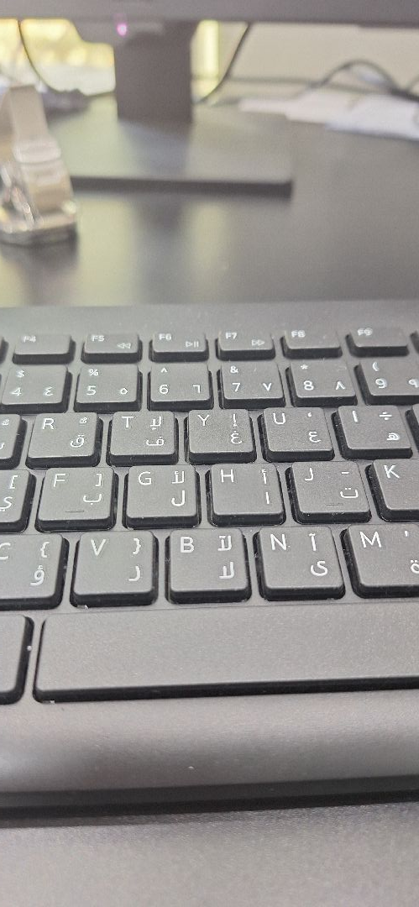
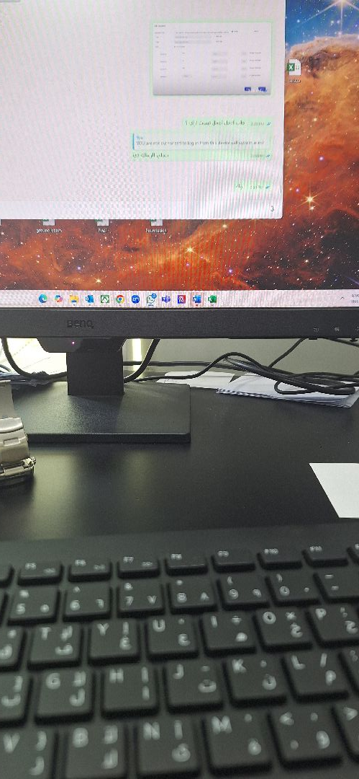

General site picture and construction plans

Checklist

No | Checklist | SBC Reference | Result | Remarks
1 | Inspection criteria
1.1 | Is the site ready for inspection with safe inspection conditions and safe access for the TIS inspection? | - | Passed
1.2 | Were there any modifications in the project that is different from the RD0, Soil Report and Construction Plans...etc.)? | - | Not Passed
1.3 | Is there any missing inspection stages in the project? | - | Passed
1.4 | Are there any defects observed that can affect the building’s stability or RD5 inspection for slab stage hasn’t been closed yet? |  | Passed
1.5 | Has the client provided verified concrete compressive strength test results? |  | Passed
1.6 | Is the laboratory conducting tests certified by an ISO/17025-accredited body? | - | Passed
2 | Formwork
2.1 | Are the forms clean and ready for pouring concrete? | - | Passed
2.2 | Is the formwork assembly stable due to the different loads? | - | Passed
2.3 | Were Concrete covers maintained as per approved drawings? | - | Passed
3 | Steel Reinforcement
3.1 | Are the longitudinal reinforcement diameter and number executed as per the construction drawing? | - | Passed
3.2 | Was the Water-stop installed as per the drawings? | - | Passed
3.3 | Is the length of splices according to the SBC specifications? | - | Passed
3.4 | Is the anchorage length of steel reinforcement at the corners of the retaining walls according to the SBC specifications? | - | Passed
3.5 | Is the steel reinforcement free from rust, oil, and contaminants? | - | Passed
3.6 | Are the tie wires installed as required? | - | Passed
3.7 | Are the bends bars within the radius and tolerance uniformly made? | - | Passed
3.8 | Is the thickness of the Retaining walls complying with the construction plans? | - | Passed
3.9 | Do the diameter, quantity, direction, and spacing of the additional longitudinal reinforcement at intersections, openings, and corners comply with the plans? | - | Passed
3.10 | Are the pipe sleeves installed as per engineering principles? | - | Passed
3.11 | Are the horizontal reinforcement diameter and number executed as per the construction drawing? | - | Passed

Risk Assessment

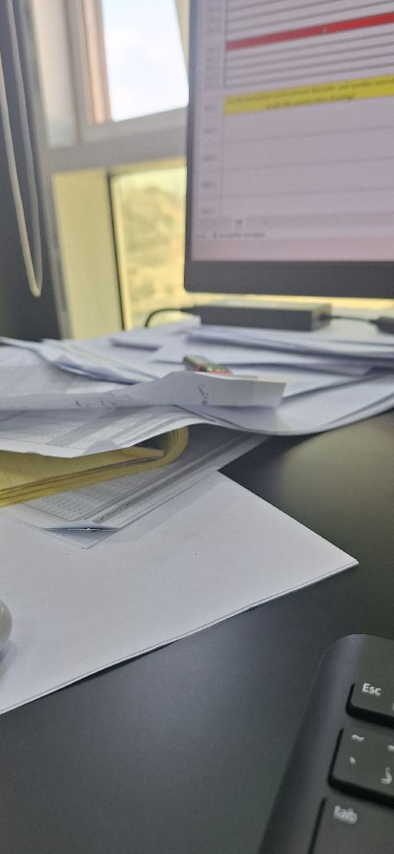

The executed works on site are not in accordance with the plans or project documents received from the client, the client must upload the updated plans or project documents to the MALATH portal. This will enable us to compare the updated plans with the executed works on site and identify the risks on the buildings based on updated documents.
Not Passed
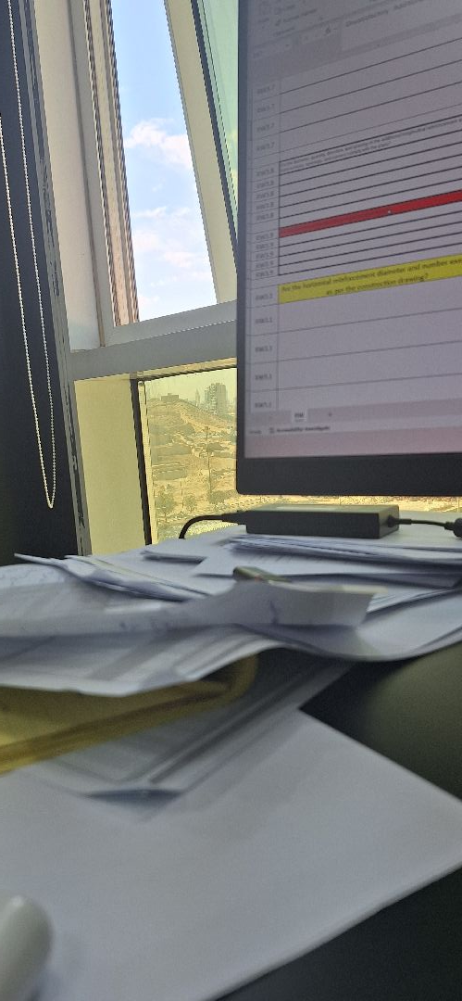

the horizontal reinforcement diameter and number are not executed as per the construction drawing
Passed
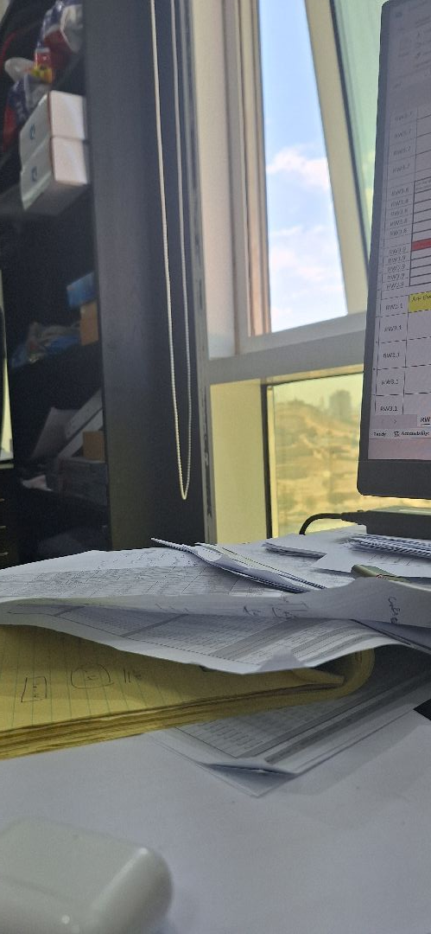

the pipe sleeves Doesn’t comply with engineering principles
Passed
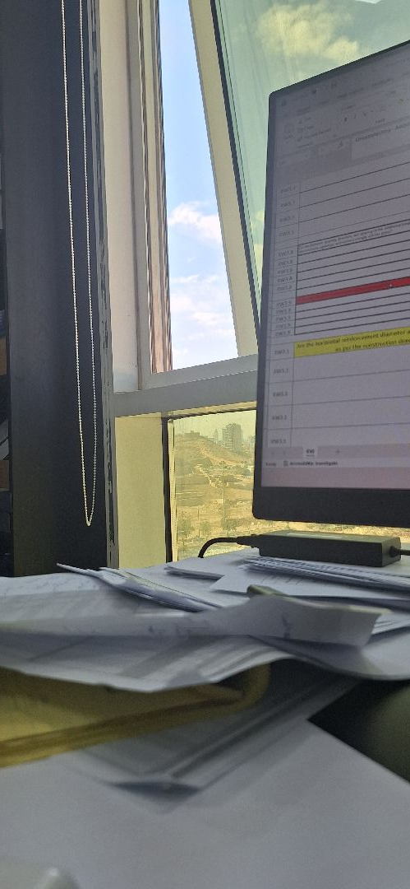

Additional steel reinforcement is not according to the construction plans, which will affect the resistance of the bending moment for the structural element.
Passed
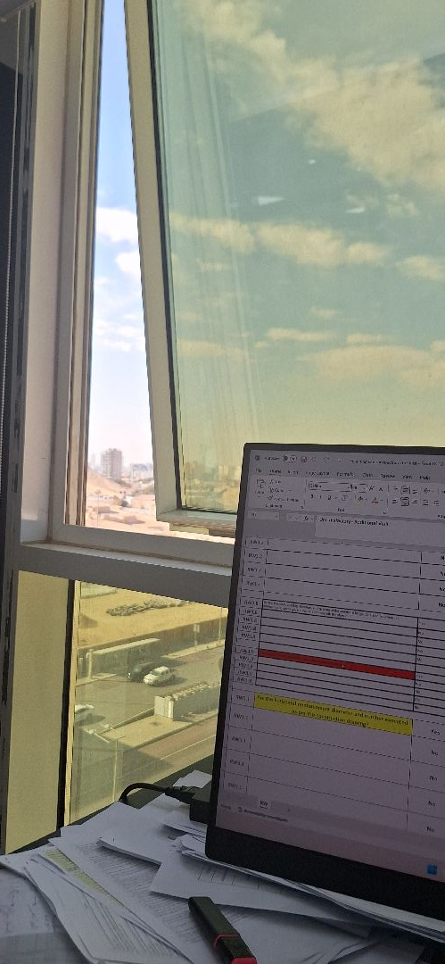

The Retaining wall thickness is not compliant with the construction plans
Passed
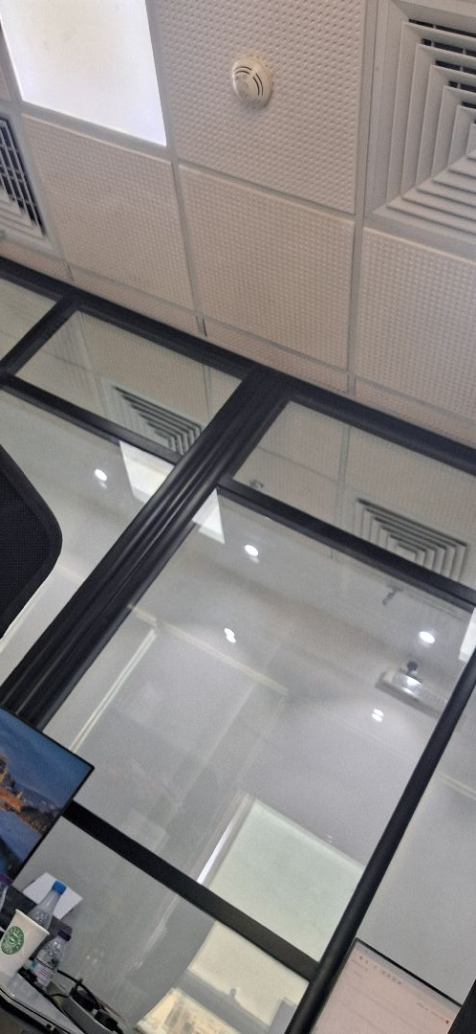

The bent bar is not as per SBC 304, installing unwanted bent bars may cause members to have less concrete cover, the intersection of stresses, or concrete segregation.
Passed
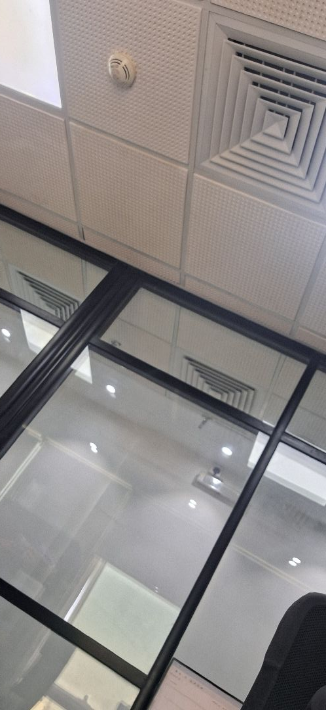

Steel bars with corrosion might decrease the bond between steel reinforcement and concrete, and the bars will be exposed to rust.
Passed
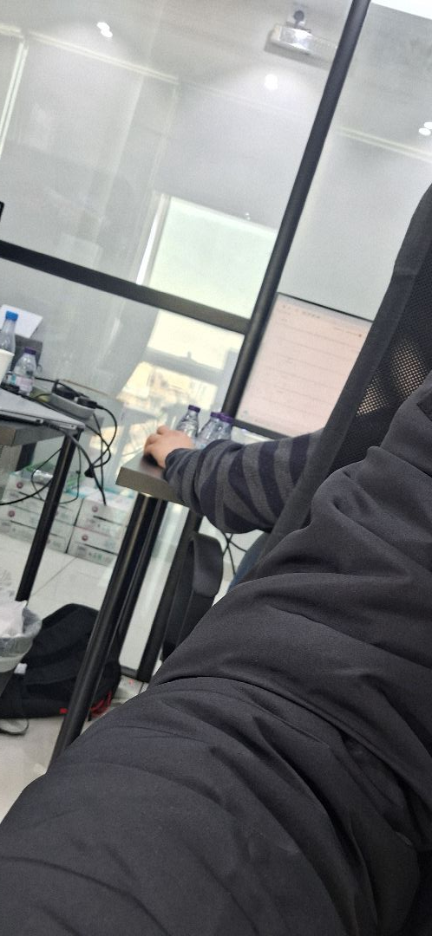

The Anchorage length of the retaining walls steel reinforcement at corners is not as per SBC 304
Passed
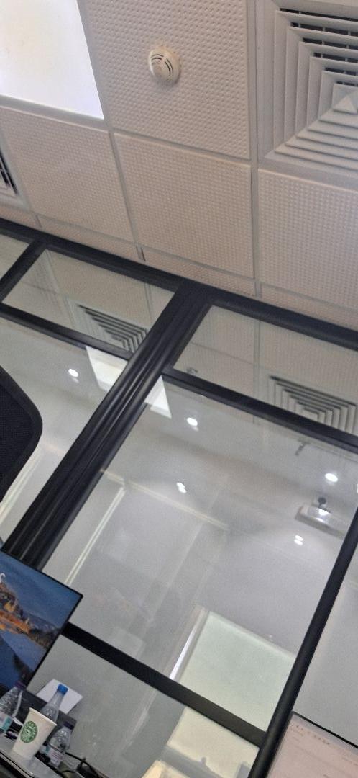

The lap splice is not as per SBC 304, which may not guarantee the normal transmission of loads and stresses between the structural members.
Passed
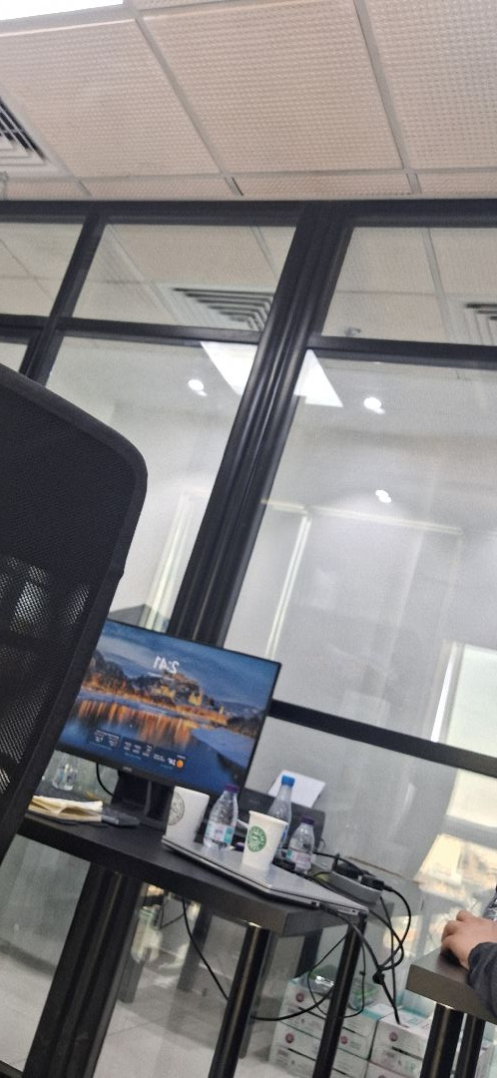

The lack of a water-stop may allow water to infiltrate the tank or basement floors, leading to potential leaks in the building and causing rust that could affect the steel reinforcement.
Passed
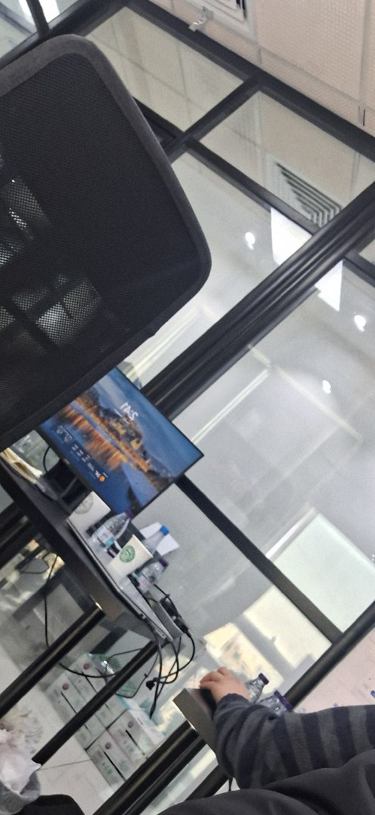

the longitudinal reinforcement diameter and number are not executed as per the construction drawing
Passed
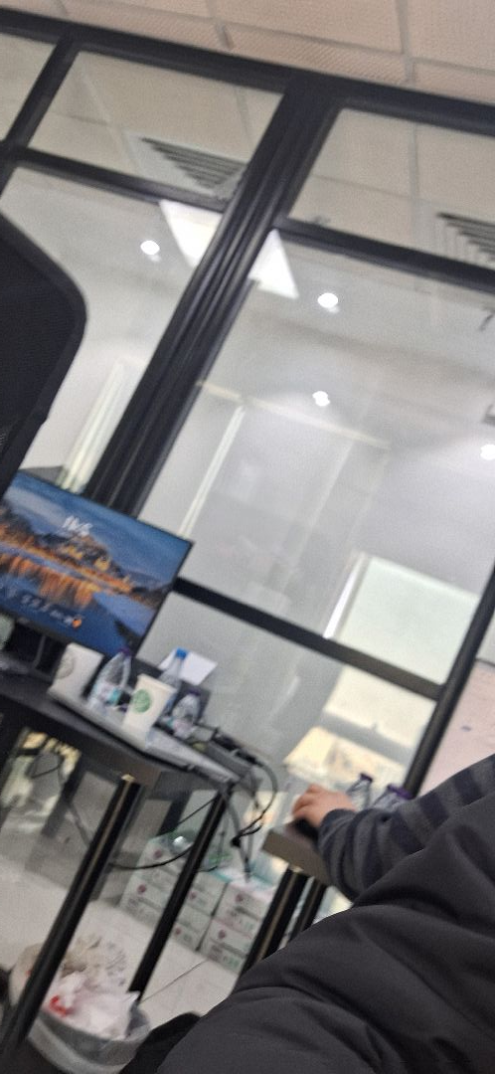

Concrete Cover
Passed
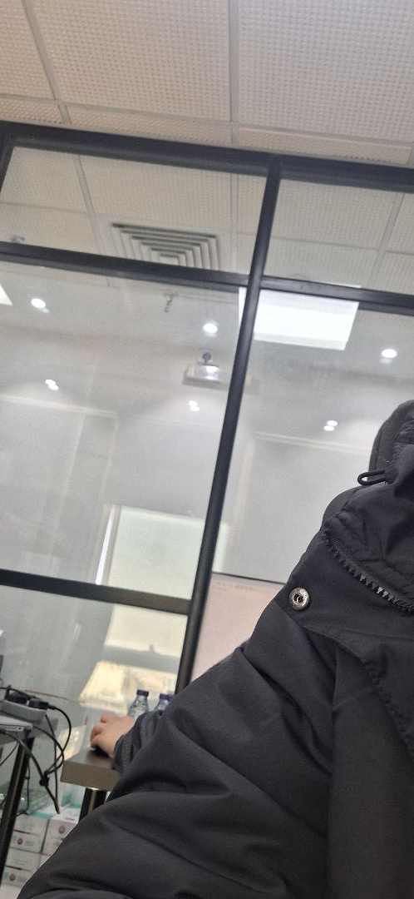

the forms are not clean and not ready for pouring concrete
Passed
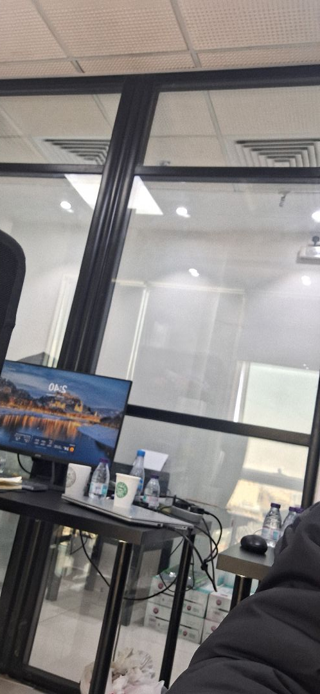

the forms are not clean and not ready for pouring concrete
Passed

Engineer In Charge of Inspection | Area Manager | Technical Inspection Manager
Name: Gamal Saad | Name: | Name:
Signature:  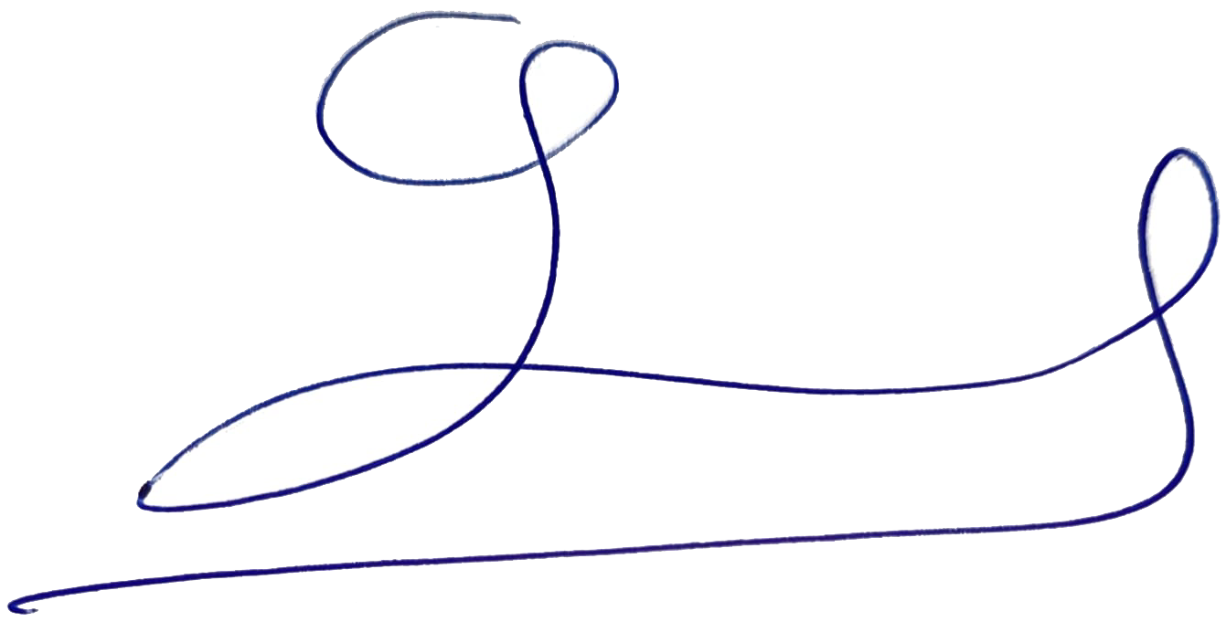 | Signature: | Signature:
Date of Issuing the report:

