${QR}

Attention to: ﻣﺆﺳﺴﺔ احمد غطاس ﻟﻠﻤﻘﺎﻭﻻﺕ

IDI PR #: 100008
Established by: Mohamed Eldapess

TIS Visit

Inspection Report - Waterproofing Envelope Assessment

Date of visit: 22-Jan-2025

Location: 24.6722033,46.7283289

( North Riyadh, Saudi Arabia)

Owner | مصطفى سامي | TIS Company | CPV Arabia
Contractor | ﻣﺆﺳﺴﺔ احمد غطاس ﻟﻠﻤﻘﺎﻭﻻﺕ | Report Issue Date
Project Location | ﻫﺒﺎﺱ | Inspection # | 7
Inspection Stage | Waterproofing Envelope Assessment | No. Of buildings | 3
Inspector Name | Mohamed Eldapess | Work in progress | Waterproofing Envelope Assessment( )
Email | meldapess@cpvarabia.com | Telephone | 581082681

Inspection Results: Satisfactory
Description of the inspections carried out:

CPV ARABIA has conducted an on-site technical inspection (IDI) for Project PR #100008 during the pre-pouring phase of the Waterproofing Envelope Assessment.

The details of the inspection are described further as we go through this report.
Summary

Risks may affect the building stability and stop the work (To be resolved by sending the required documents):
- Not exist
Stages missed without TIS involvement (To be resolved by performing the required tests for the missed elements):
- The project has a missing stage as shown in the attached image
Interpretation of Additional Visit:
- sasassasasasa- good morning you can
Technical Reservations (To be closed by providing the required certificates and reports before the final visit):
- Not exist
Note:
- I can get it - you can get it done

General Site Pictures and Construction Plans
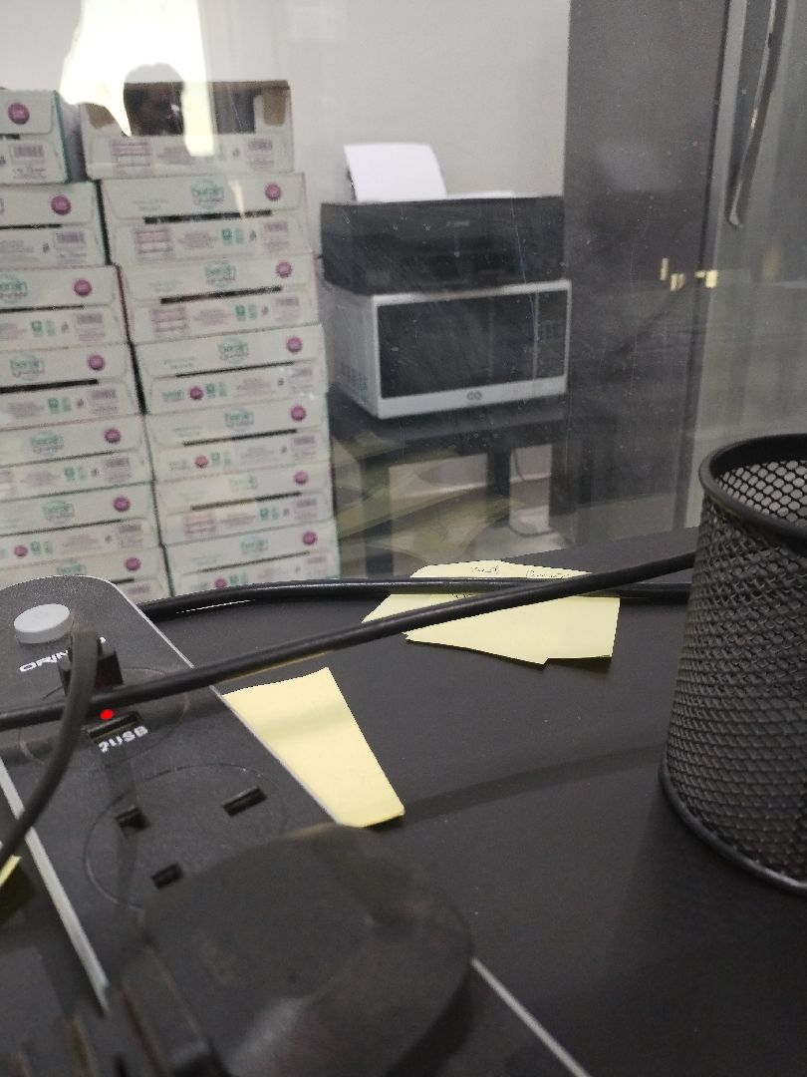

General site picture and construction plans

Risk Assessment

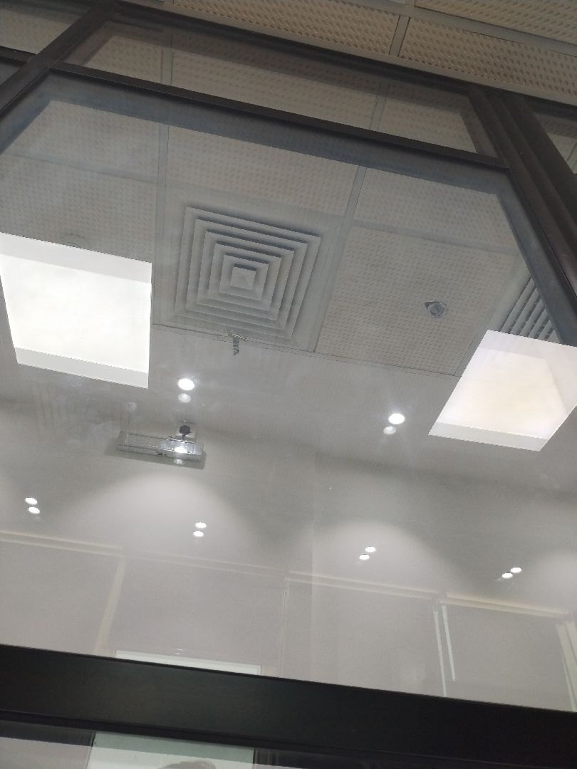

There are no defects in the basement waterproofing
Passed
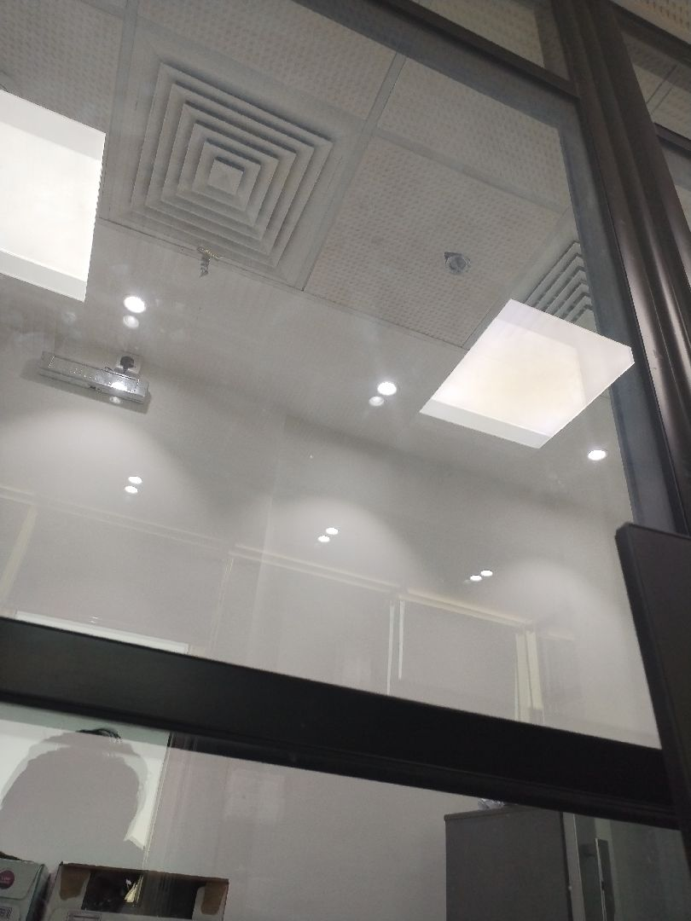

There are no defects in the basement waterproofing
Passed
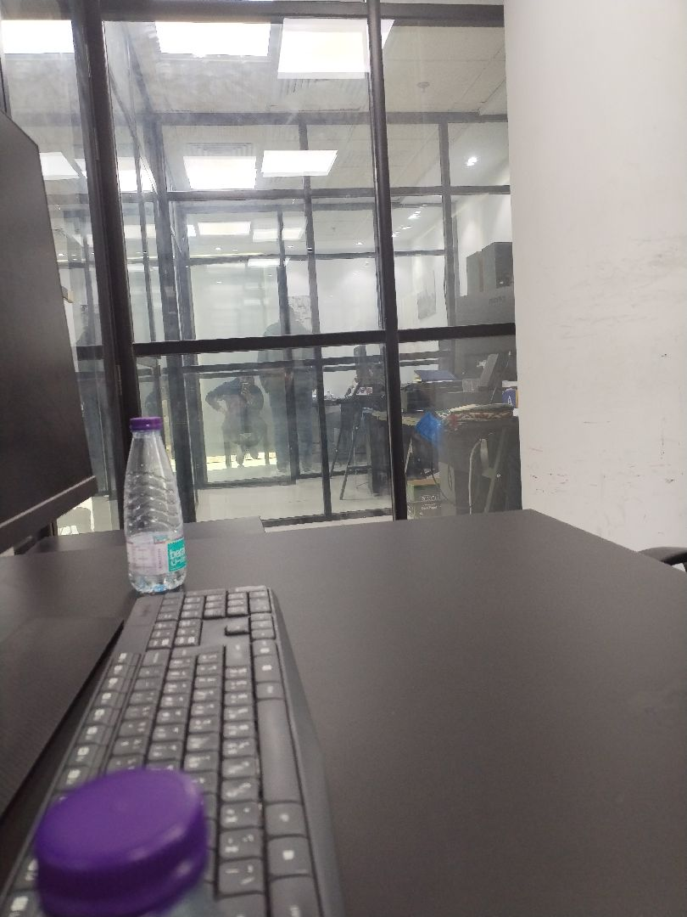

There are no defects in the facade waterproofing
Passed
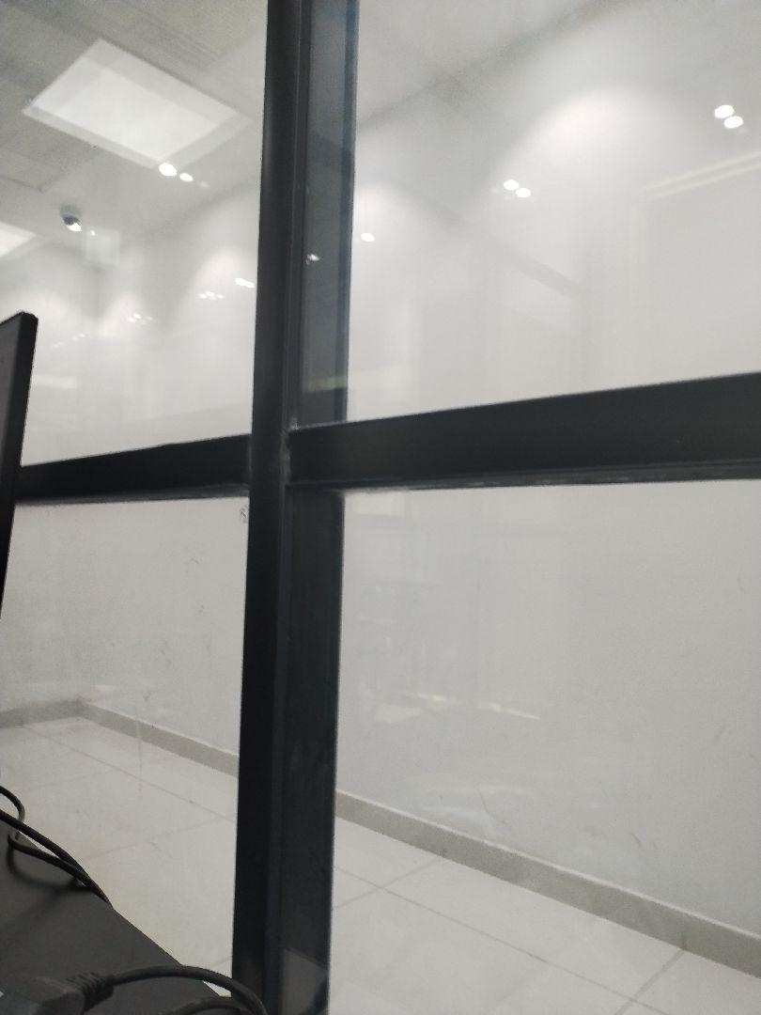

There are no defects in the facade waterproofing
Passed
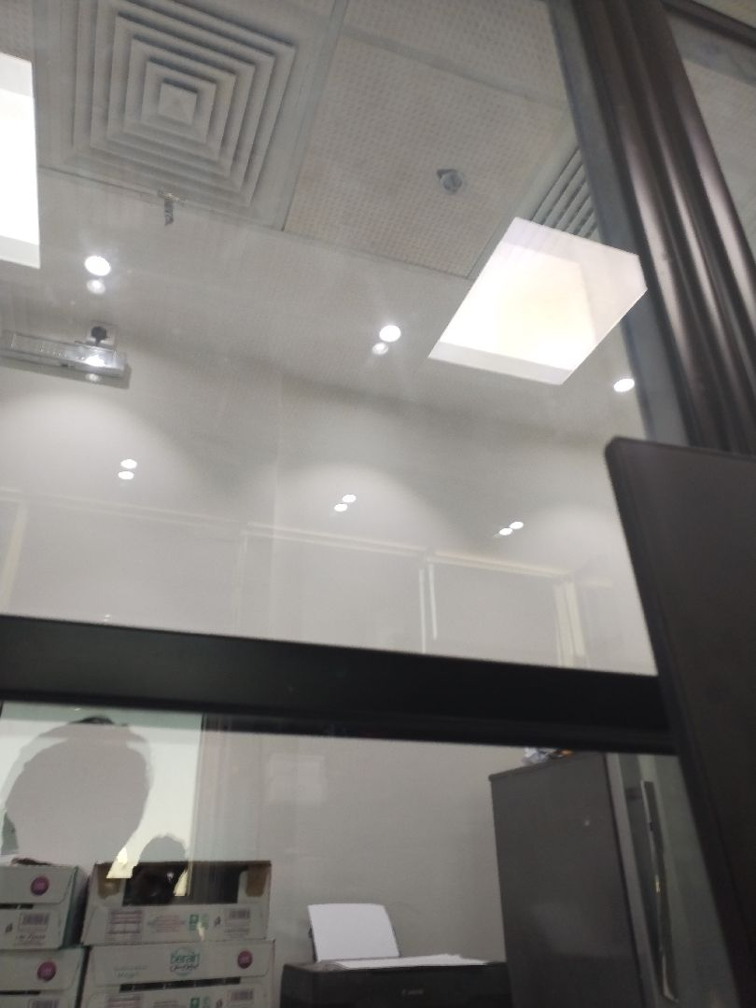

There are no defects in the facade waterproofing
Passed
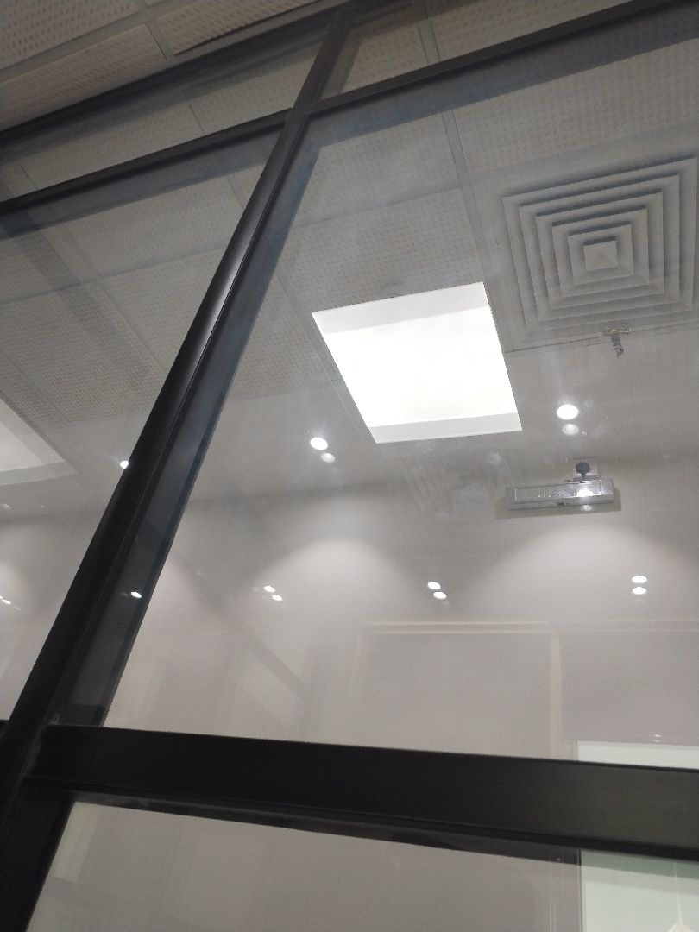

There are no defects in the facade waterproofing
Passed
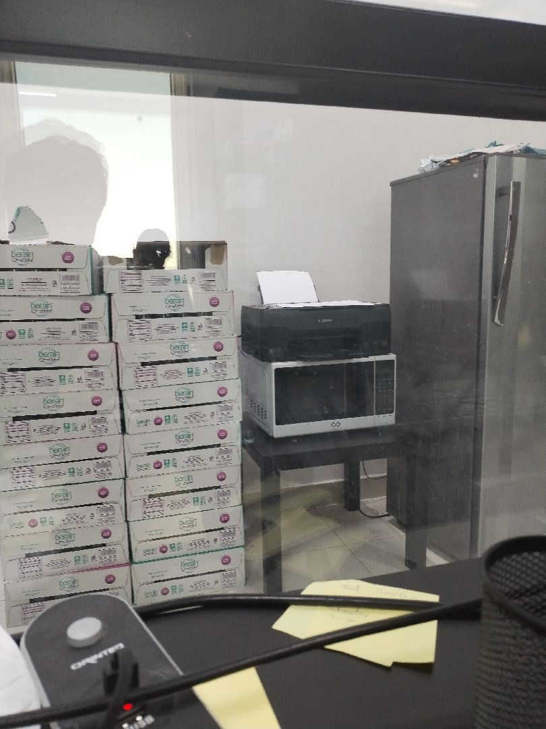

There are no defects in the roof waterproofing
Passed
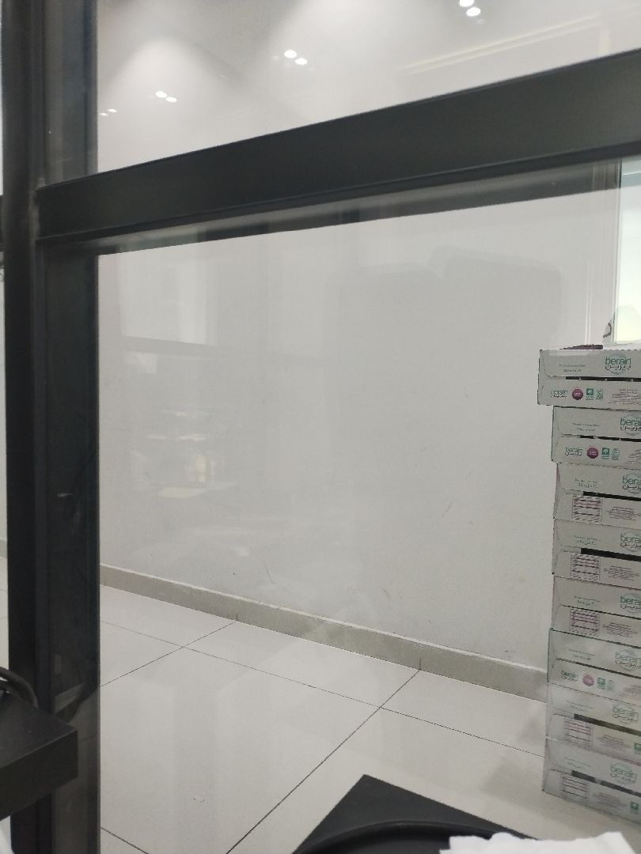

There are no defects in the roof waterproofing
Passed
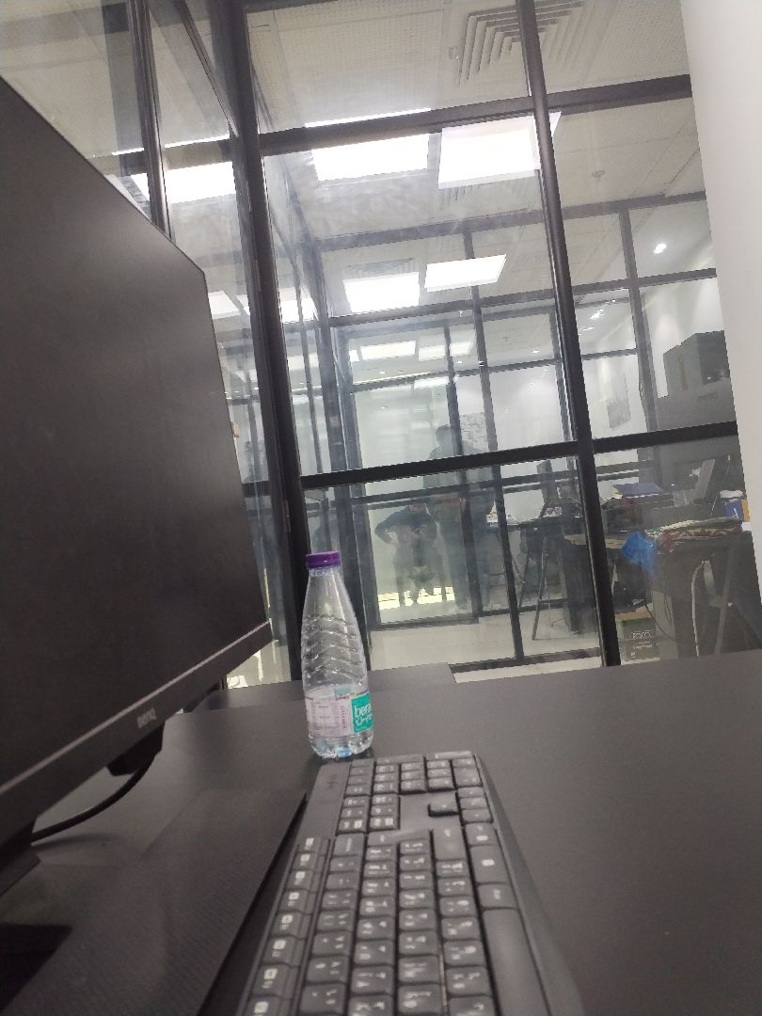

There are no defects in the roof waterproofing
Passed
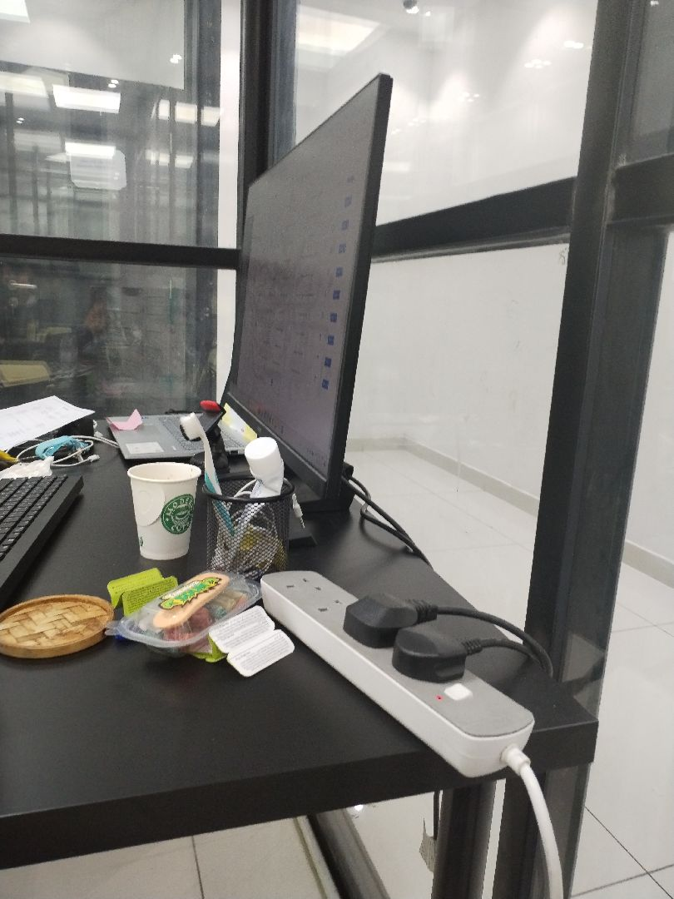

There are no defects in the roof waterproofing
Passed

Engineer In Charge of Inspection | Special Projects Manager | Technical Inspection Manager
Name: Mohamed Eldapess | Name: | Name:
Signature:  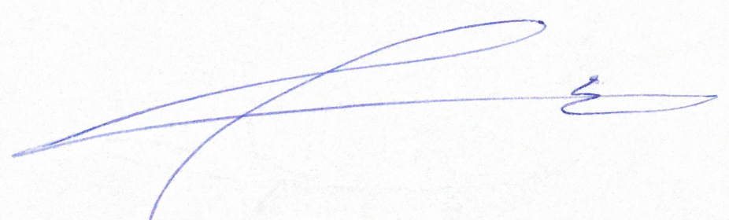 | Signature: | Signature:
Date of Issuing the report:

