${QR}

Attention to: ﻣﺆﺳﺴﺔ ﻋﻨﻴﻔﻪ ﺳﻠﻴﻤﺎﻥ ﺑﻦ ﻋﻠﻴﺎﻥ ﺍﻟﺮﺷﻴﺪﻱ ﻟﻠﻤﻘﺎﻭﻻﺕ ﺍﻟﻌﺎﻣﺔ

IDI PR #: 123111
Established by: Amr Yasser

TIS Visit

Inspection Report - Retaining walls

Date of visit: 09-Feb-2025

Location: 26.3968055,50.0717648

( Special Projects, Saudi Arabia)

Owner | ﺿﻴﻒ ﺍﻟﻠﻪ ﺑﻦ ﻣﺤﻤﺪ ﺑﻦ ﻣﺜﻌﻲ ﺍﻟﻌﺘﻴﺒﻲ | TIS Company | CPV Arabia
Contractor | ﻣﺆﺳﺴﺔ ﻋﻨﻴﻔﻪ ﺳﻠﻴﻤﺎﻥ ﺑﻦ ﻋﻠﻴﺎﻥ ﺍﻟﺮﺷﻴﺪﻱ ﻟﻠﻤﻘﺎﻭﻻﺕ ﺍﻟﻌﺎﻣﺔ | Report Issue Date
Project Location | ﺍﻟﻘﻄﻌﺔ ﺭﻗﻢ 701 ﻣﺨﻄﻂ 92*6 ﺍﻟﻤﻨﺘﺰﺓ ﺭﺍﺱ ﺗﻨﻮﺭ | Inspection # | 1
Inspection Stage | Retaining walls | No. Of buildings | 1
Inspector Name | Amr Yasser | Work in progress | Retaining walls
Email | ayasser@cpvarabia.com | Telephone | 594037209

Inspection Results: Satisfactory
Description of the inspections carried out:

CPV ARABIA has conducted an on-site technical inspection (IDI) for Project PR #123111 during the pre-pouring phase of the Retaining walls .

The details of the inspection are described further as we go through this report.
Summary

Risks Assessment:
- The load is applied incrementally not as per approved standards (e.g., ASTM D1196). the load is applied incrementally should comply the approved standards (e.g., ASTM D1196).- The compaction test results for the previous layers have not been provided and have not been verified on-site The compaction test results for the previous layers must be provided and verified on-site.
Stages missed without TIS involvement:
- Not exist
Interpretation of Additional Visit:
- The test area is not level, not free from debris, and not prepared according to the approved method statement

General Site Pictures and Construction Plans
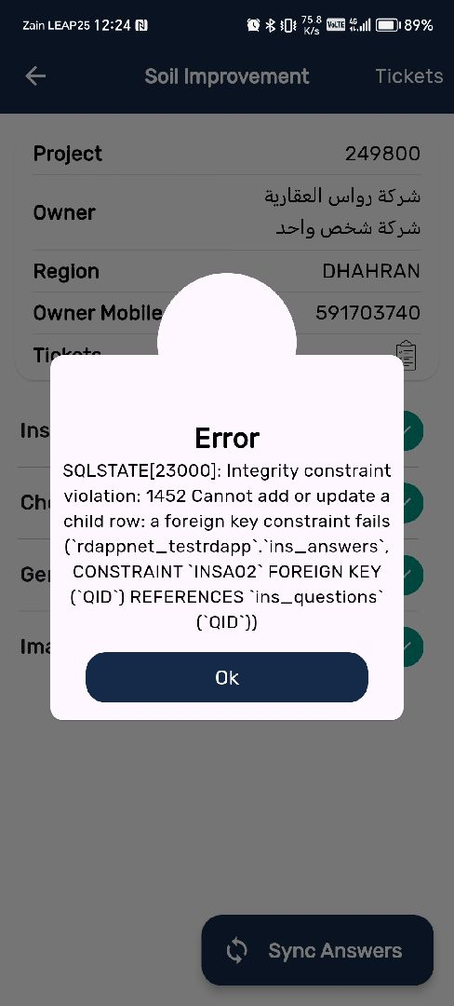
${CImg}

General site picture and construction plans

Checklist

No | Checklist | SBC Reference | Result | Remarks
1 | Inspection criteria
1.1 | Is the site ready for inspection with safe inspection conditions and safe access for the TIS inspection? | - | Passed
1.2 | Were there any modifications in the project that is different from the RD0, Soil Report and Construction Plans...etc.)? | - | Passed
1.3 | Is there any missing inspection stages in the project? | - | Passed
1.4 | Are there any defects observed that can affect the building’s stability or RD5 inspection for slab stage hasn’t been closed yet? |  | Passed
1.5 | Has the client provided verified concrete compressive strength test results? |  | NA
1.6 | Is the laboratory conducting tests certified by an ISO/17025-accredited body? | - | NA
2 | Formwork
2.1 | Are the forms clean and ready for pouring concrete? | - | Passed
2.2 | Is the formwork assembly stable due to the different loads? | - | Passed
2.3 | Were Concrete covers maintained as per approved drawings? | - | Passed
3 | Steel Reinforcement
3.1 | Are the longitudinal reinforcement diameter and number executed as per the construction drawing? | - | Passed
3.2 | Was the Water-stop installed as per the drawings? | - | Passed
3.3 | Is the length of splices according to the SBC specifications? | - | Passed
3.4 | Is the anchorage length of steel reinforcement at the corners of the retaining walls according to the SBC specifications? | - | Passed
3.5 | Is the steel reinforcement free from rust, oil, and contaminants? | - | Passed
3.6 | Are the tie wires installed as required? | - | Passed
3.7 | Are the bends bars within the radius and tolerance uniformly made? | - | Passed
3.8 | Is the thickness of the Retaining walls complying with the construction plans? | - | Passed
3.9 | Do the diameter, quantity, direction, and spacing of the additional longitudinal reinforcement at intersections, openings, and corners comply with the plans? | - | Passed
3.10 | Are the pipe sleeves installed as per engineering principles? | - | Passed
3.11 | Are the horizontal reinforcement diameter and number executed as per the construction drawing? | - | Passed

Risk Assessment

${RAPage}
${BTicketImag}

${Description}
${Passed}

Engineer In Charge of Inspection | Area Manager | Technical Inspection Manager
Name: Amr Yasser | Name: | Name:
Signature:  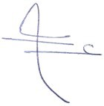 | Signature: | Signature:
Date of Issuing the report:

