${QR}

Attention to: ﺷﺮﻛﺔ ﻗﻤﻢ ﺍﻟﺘﺸﻴﻴﺪ ﻟﻠﻤﻘﺎﻭﻻﺕ

IDI PR #: 127514
Established by: Mohamed Eldapess

TIS Visit

Inspection Report - Waterproofing Envelope Assessment

Date of visit: 04-Mar-2025

Location: 24.6723161,46.7282493

( North Riyadh, Saudi Arabia)

Owner | علاء صقر | TIS Company | CPV Arabia
Contractor | ﺷﺮﻛﺔ ﻗﻤﻢ ﺍﻟﺘﺸﻴﻴﺪ ﻟﻠﻤﻘﺎﻭﻻﺕ | Report Issue Date
Project Location | ﺣﻲ ﺍﻟﻴﺮﻣﻮﻙ - ﺍﻻﺣﺴﺎﺀ | Inspection # | 2
Inspection Stage | Waterproofing Envelope Assessment | No. Of buildings | 1
Inspector Name | Mohamed Eldapess | Work in progress | Waterproofing Envelope Assessment
Email | meldapess@cpvarabia.com | Telephone | 581082681

Inspection Results: Satisfactory with Note
Description of the inspections carried out:

CPV ARABIA has conducted an on-site technical inspection (IDI) for Project PR #127514 during the pre-pouring phase of the Waterproofing Envelope Assessment.

The details of the inspection are described further as we go through this report.
Summary

Risks may affect the building stability and stop the work (To be resolved by sending the required documents):
- Not exist
Stages missed without TIS involvement (To be resolved by performing the required tests for the missed elements):
- Not exist
Interpretation of Additional Visit:
- Not exist
Technical Reservations (To be closed by providing the required certificates and reports before the final visit):
- Not exist
Note:
- There are minor defects in the facade waterproofing- There are minor defects in the roof waterproofing

General Site Pictures and Construction Plans
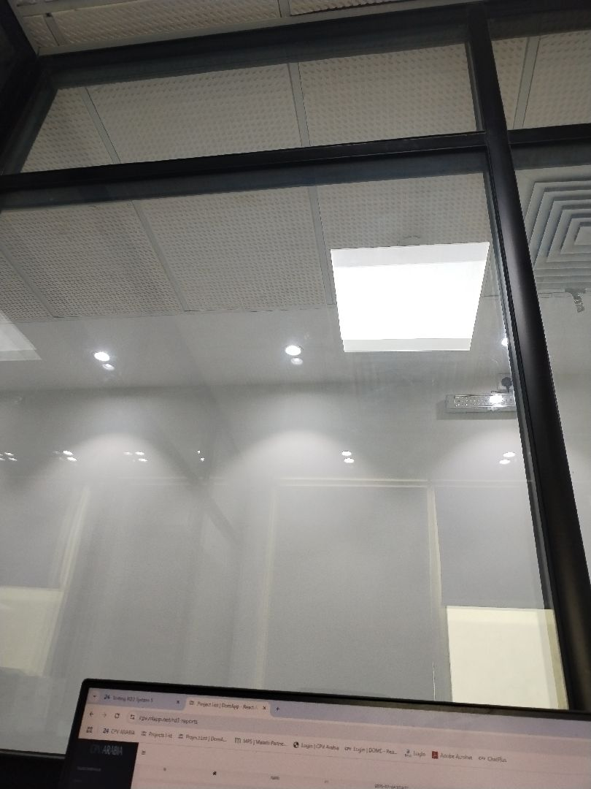

General site picture and construction plans

Risk Assessment

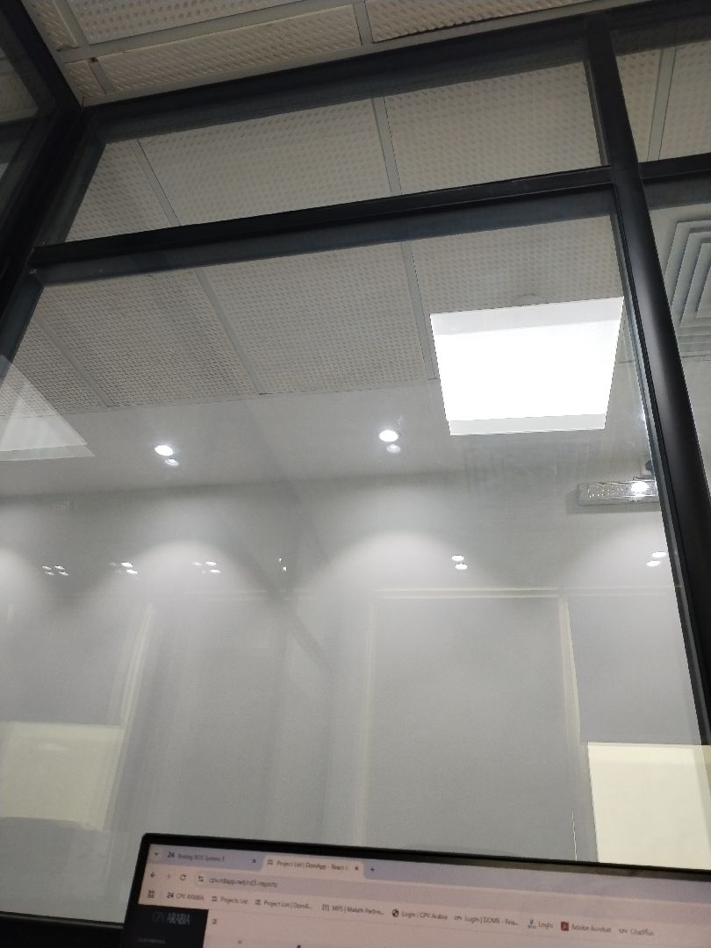

There are minor defects in the facade waterproofing
Passed
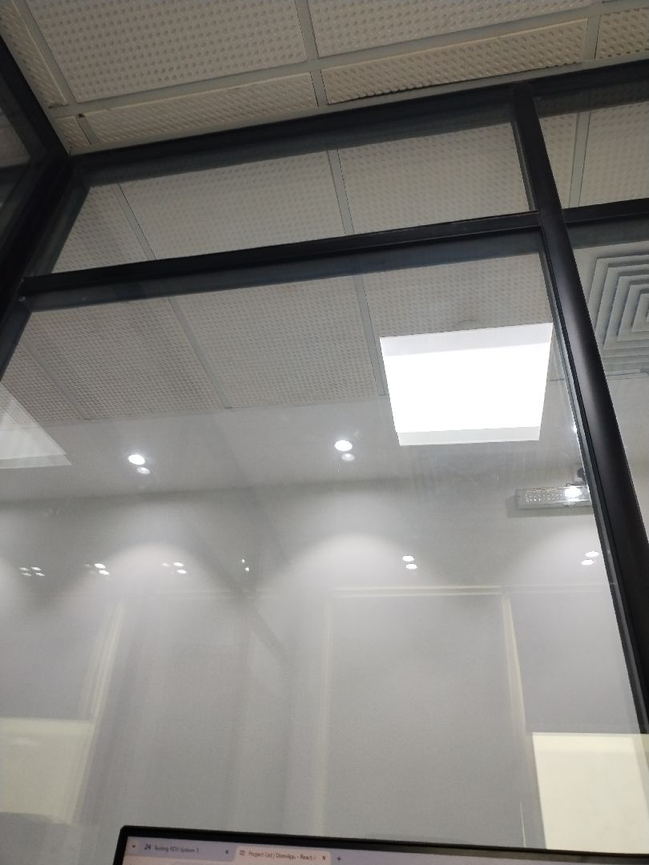

There are minor defects in the facade waterproofing
Passed
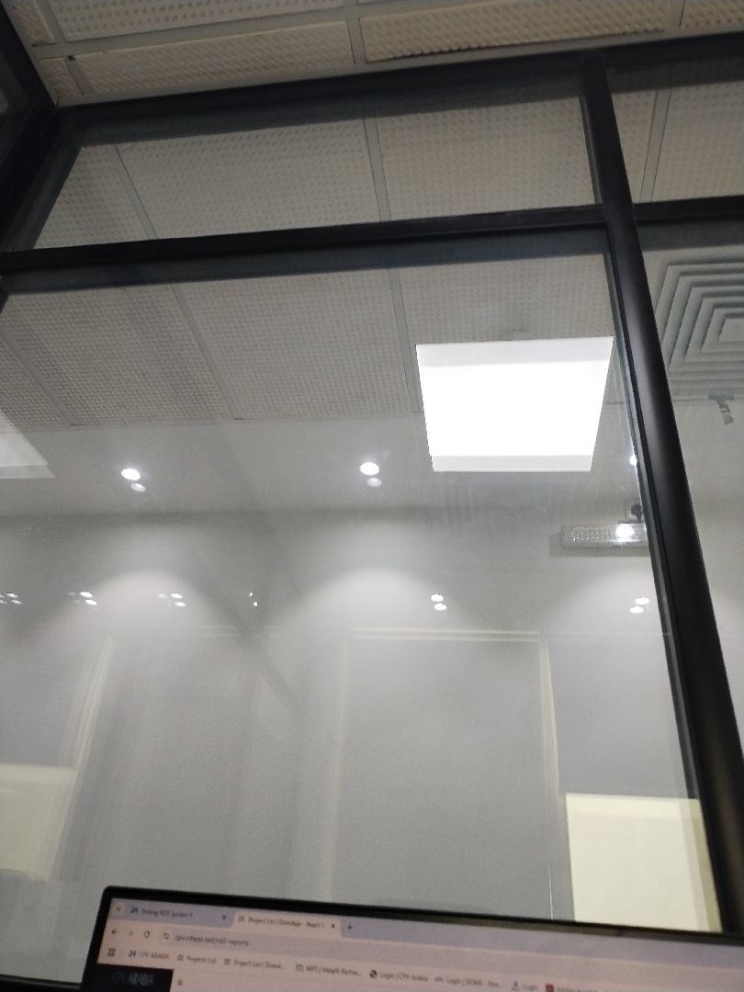

There are minor defects in the roof waterproofing
Passed
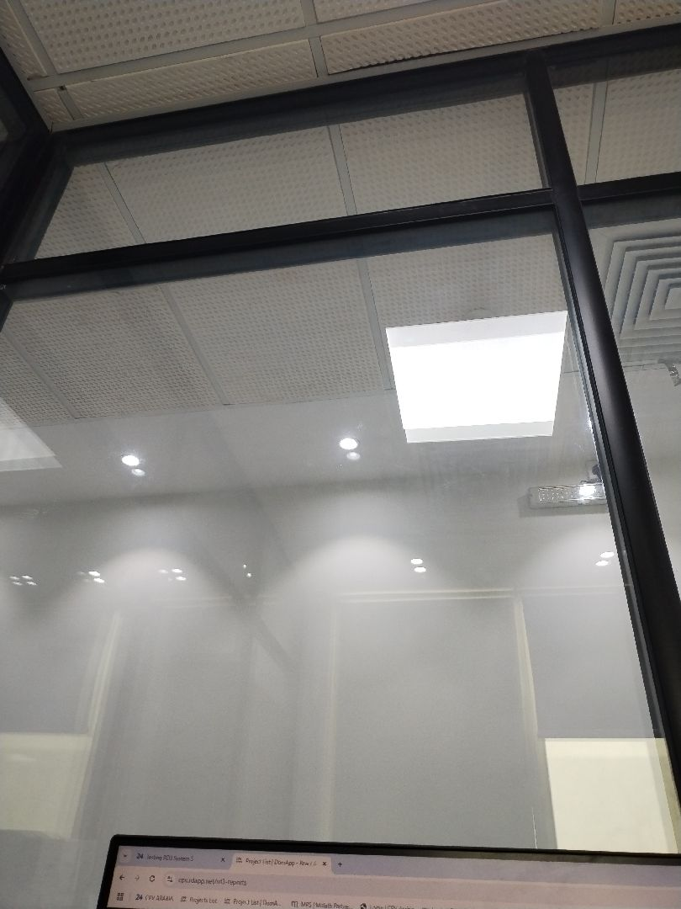

There are minor defects in the roof waterproofing
Passed

Engineer In Charge of Inspection | Area Manager | Technical Inspection Manager
Name: Mohamed Eldapess | Name: | Name:
Signature:  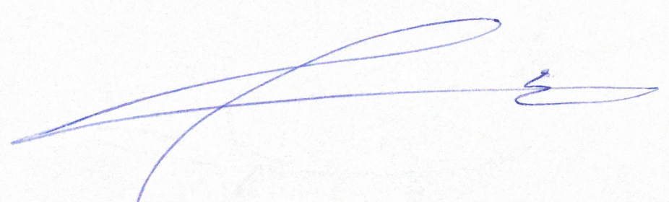 | Signature: | Signature:
Date of Issuing the report:

