${QR}

Attention to: ﻣﺆﺳﺴﺔ ﺍﻋﻤﺎﺭ ﻛﺮﺍ ﻟﻠﻤﻘﺎﻭﻻﺕ ﺍﻟﻌﺎﻣﺔ

IDI PR #: 190019
Established by: Adel Alharbi

TIS Visit

Inspection Report - Waterproofing Envelope Assessment

Date of visit: 18-Mar-2025

Location: 24.6723952,46.7283754

( Madina Branch, Saudi Arabia)

Owner | ﻣﺒﺎﺭﻙ ﺩﺍﻳﺲ ﻣﺒﺎﺭﻙ ﺍﻟﺰﻫﺮﺍﻧﻲ | TIS Company | CPV Arabia
Contractor | ﻣﺆﺳﺴﺔ ﺍﻋﻤﺎﺭ ﻛﺮﺍ ﻟﻠﻤﻘﺎﻭﻻﺕ ﺍﻟﻌﺎﻣﺔ | Report Issue Date
Project Location | 537 ﻣﻨﻄﻘﺔ ﺍﻟﺒﺎﺣﺔ - ﻣﺤﺎﻓﻈﺔ ﺍﻟﻌﻘﻴﻖ - ﻣﺨﻄﻂ ﺭﻗﻢ 944 - ﻗﻄﻌﺔ ﺭﻗﻢ | Inspection # | 1
Inspection Stage | Waterproofing Envelope Assessment | No. Of buildings | 1
Inspector Name | Adel Alharbi | Work in progress | Waterproofing Envelope Assessment
Email | AAlharbi@cpvarabia.com | Telephone | 596259946

Inspection Results: Satisfactory
Description of the inspections carried out:

CPV ARABIA has conducted an on-site technical inspection (IDI) for Project PR #190019 during the pre-pouring phase of the Waterproofing Envelope Assessment.

The details of the inspection are described further as we go through this report.
Summary

Risks may affect the building stability and stop the work (To be resolved by sending the required documents):
- Not exist
Stages missed without TIS involvement (To be resolved by performing the required tests for the missed elements):
- Not exist
Interpretation of Additional Visit:
- Not exist
Technical Reservations (To be closed by providing the required certificates and reports before the final visit):
- Not exist
Note:
- Not exist

General Site Pictures and Construction Plans
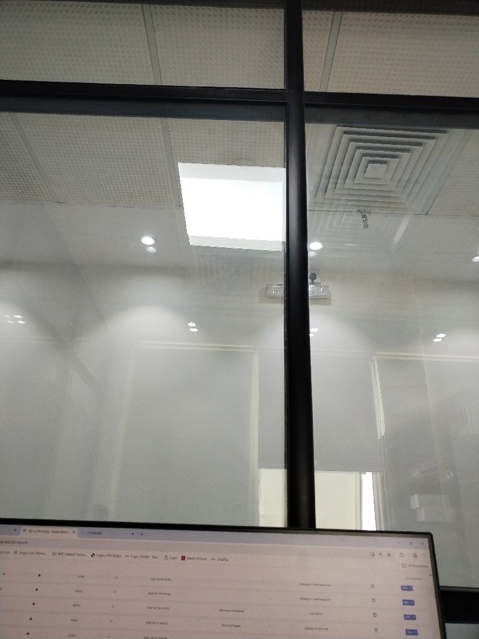

General site picture and construction plans

Risk Assessment

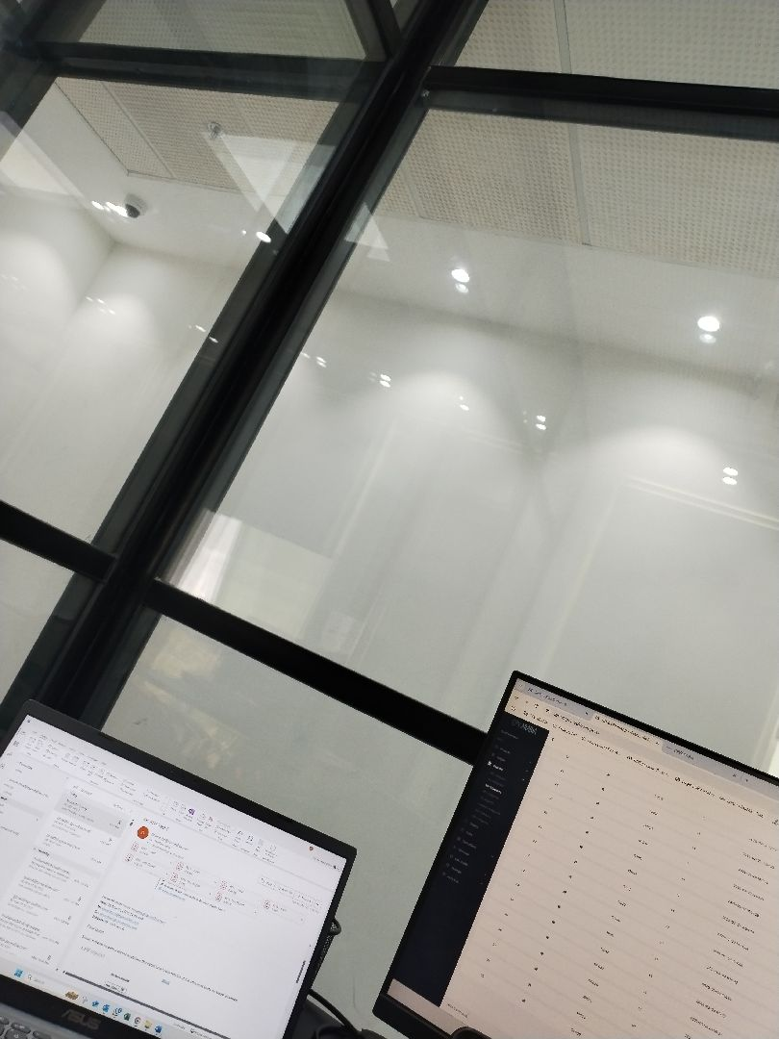

There are no defects in the basement waterproofing
Passed
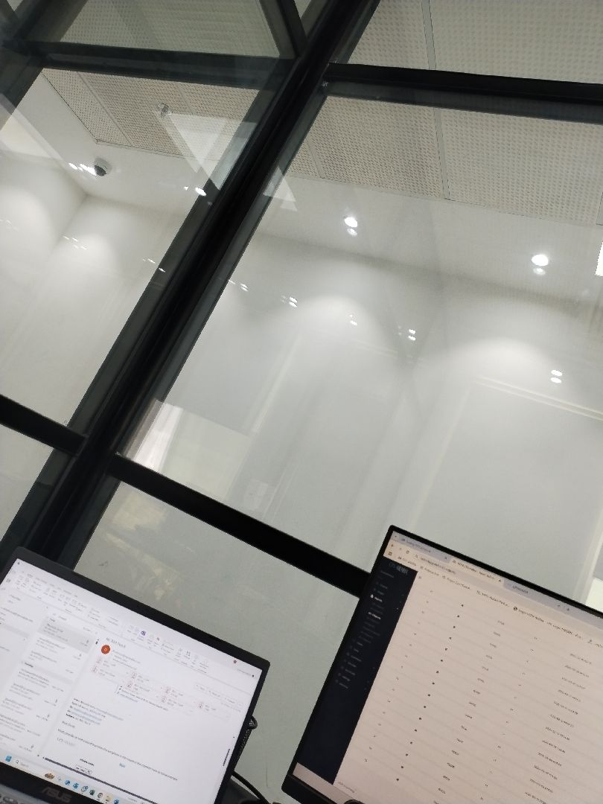

There are no defects in the basement waterproofing
Passed
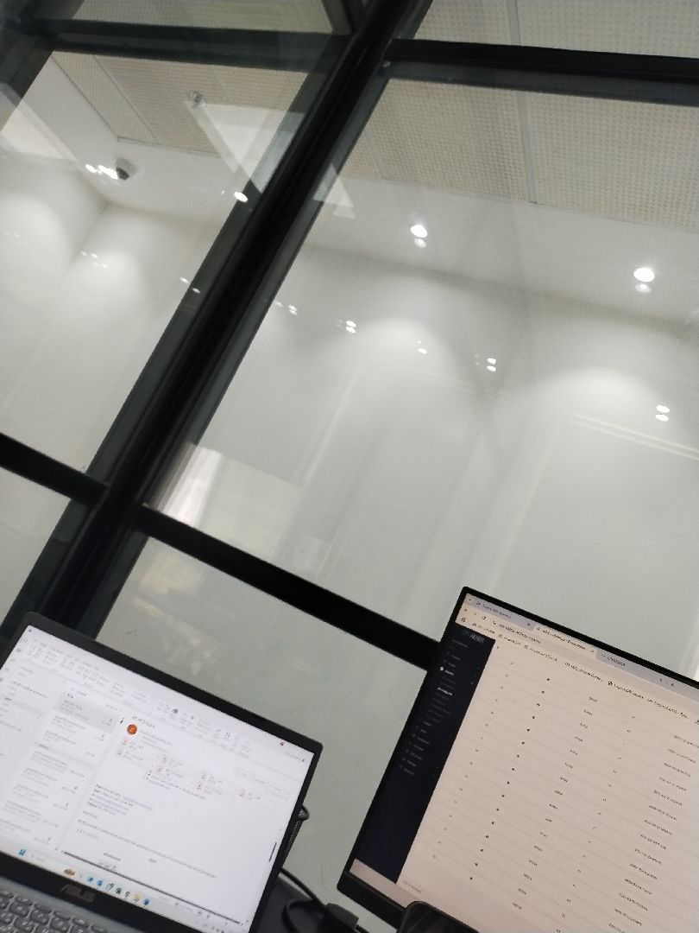

There are no defects in the basement waterproofing
Passed
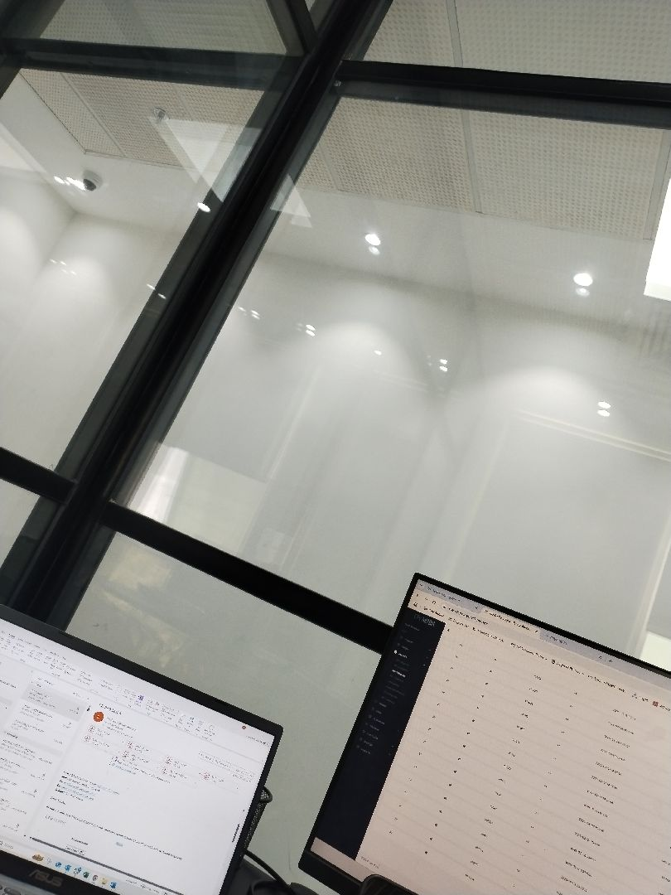

There are no defects in the basement waterproofing
Passed
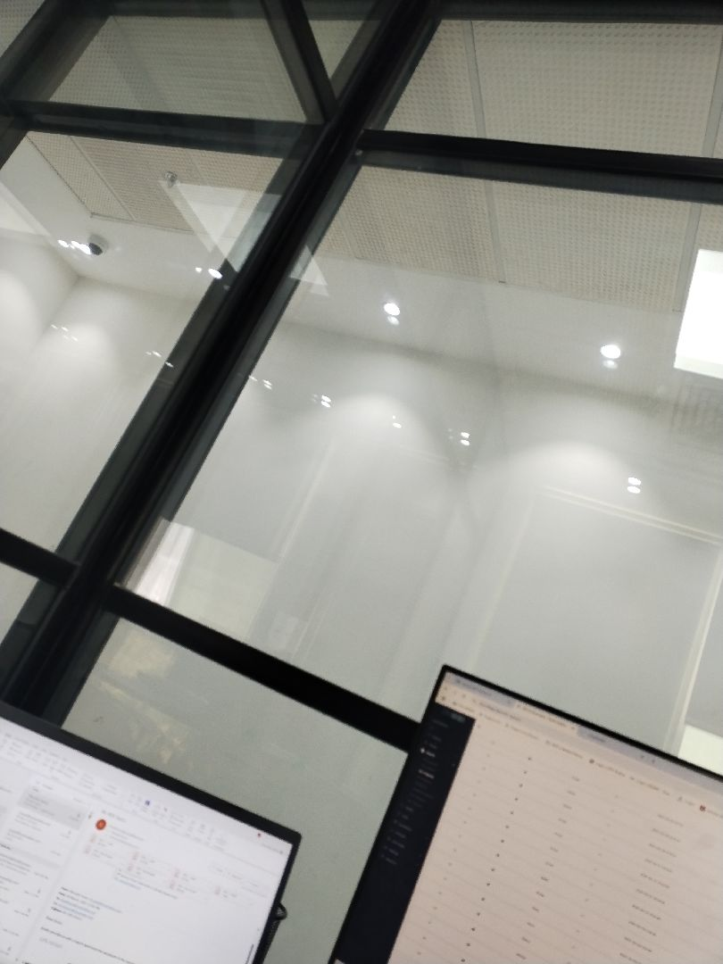

There are no defects in the facade waterproofing
Passed
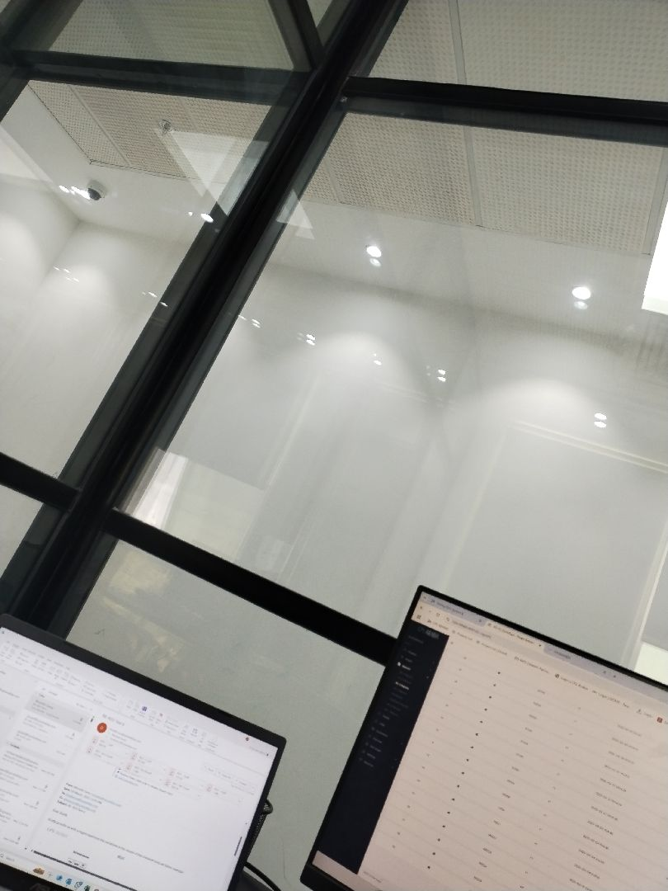

There are no defects in the facade waterproofing
Passed
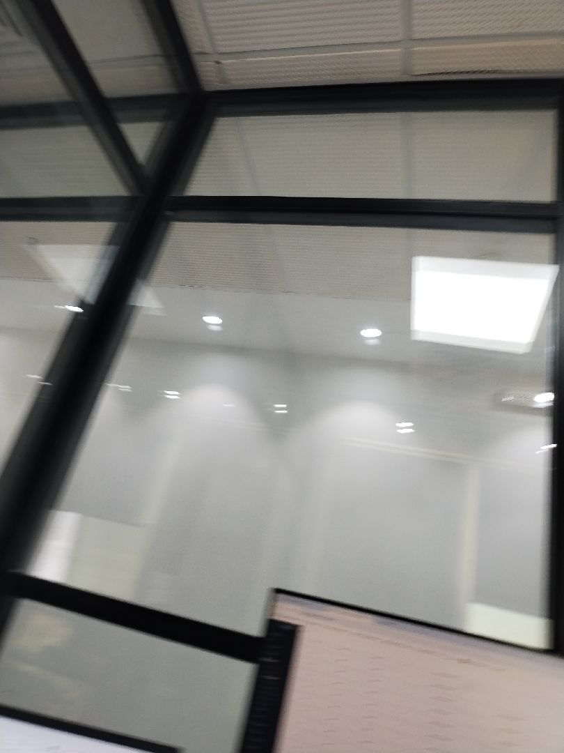

There are no defects in the roof waterproofing
Passed
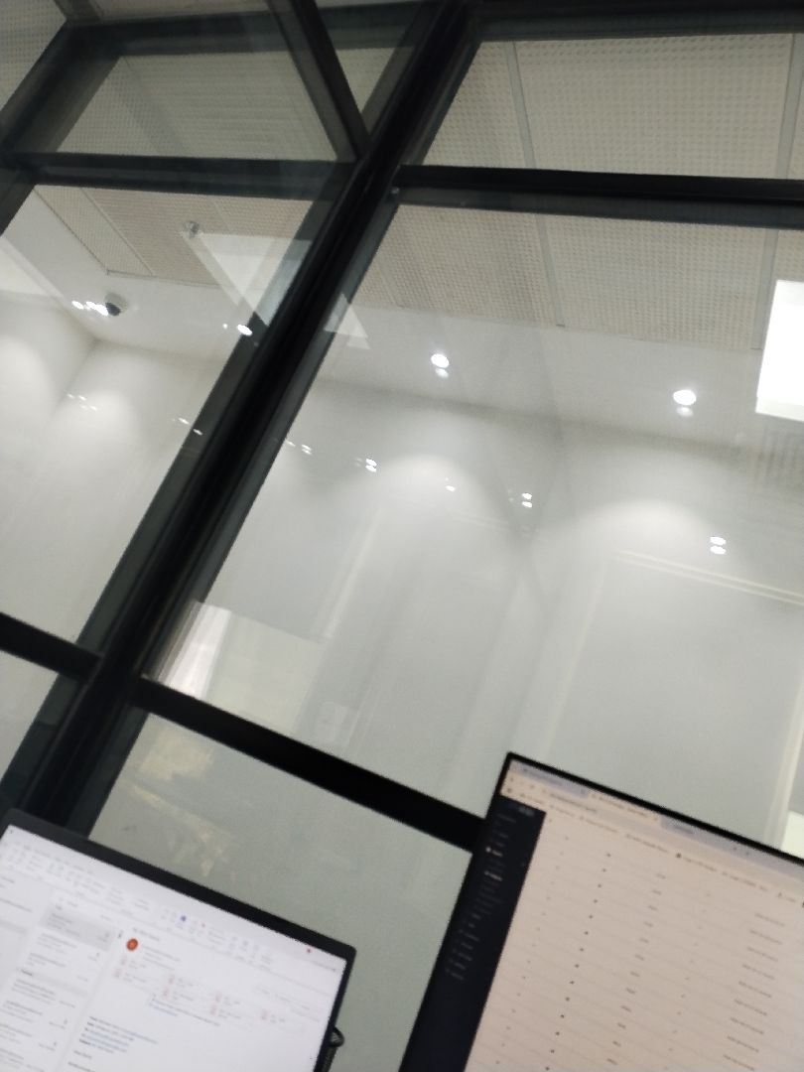

There are no defects in the roof waterproofing
Passed

Engineer In Charge of Inspection | Area Manager | Technical Inspection Manager
Name: Adel Alharbi | Name: | Name:
Signature:   | Signature: | Signature:
Date of Issuing the report:

