${QR}

Attention to: ﻣﺆﺳﺴﺔ ﺧﻠﻒ ﻧﺎﻓﻊ ﺍﻟﺤﺮﺑﻲ ﻟﻠﻤﻘﺎﻭﻻﺕ

IDI PR #: 296082
Established by: Mahmoud Al Moghazi

TIS Visit

Inspection Report - Waterproofing Envelope Assessment

Date of visit: 22-Jan-2025

Location: 24.6721982,46.7283265

( Madina Branch, Saudi Arabia)

Owner | ﺳﻌﻮﺩ ﺧﻠﻒ ﻧﺎﻓﻊ ﺍﻟﺤﺮﺑﻲ | TIS Company | CPV Arabia
Contractor | ﻣﺆﺳﺴﺔ ﺧﻠﻒ ﻧﺎﻓﻊ ﺍﻟﺤﺮﺑﻲ ﻟﻠﻤﻘﺎﻭﻻﺕ | Report Issue Date
Project Location | ﺍﻟﻤﺪﻳﻨﺔ ﺍﻟﻤﻨﻮﺭﺓ - ﺑﻠﺪﻳﺔ ﺍﻟﻌﻘﻴﻖ - ﺣﻲ ﺍﻟﺼﻨﺎﻋﻴﺔ | Inspection # | 2
Inspection Stage | Waterproofing Envelope Assessment | No. Of buildings | 1
Inspector Name | Mahmoud Al Moghazi | Work in progress | Waterproofing Envelope Assessment
Email | Malmoghzy@cpvarabia.com | Telephone | 581145387

Inspection Results: Satisfactory
Description of the inspections carried out:

CPV ARABIA has conducted an on-site technical inspection (IDI) for Project PR #296082 during the pre-pouring phase of the Waterproofing Envelope Assessment.

The details of the inspection are described further as we go through this report.
Summary

Risks may affect the building stability and stop the work (To be resolved by sending the required documents):
- The location of the (water tank/ Septic tank) was not specified on the plans. It must be considered that the location of the tank near the building affects the stability of the building’s foundations and exposes the structure to risk. If the (water tank Septic tank) is located inside or near the building, please provide a warranty certificate for the internal and external insulation. If they are located inside the building, a structural design review is provided to verify the effect of lateral soil pressure on the side walls of the tank.
Stages missed without TIS involvement (To be resolved by performing the required tests for the missed elements):
- Not exist
Interpretation of Additional Visit:
- Not exist
Technical Reservations (To be closed by providing the required certificates and reports before the final visit):
- The ground slab is supported on a backfill of more than 30cm.
Note:
- Not exist

General Site Pictures and Construction Plans
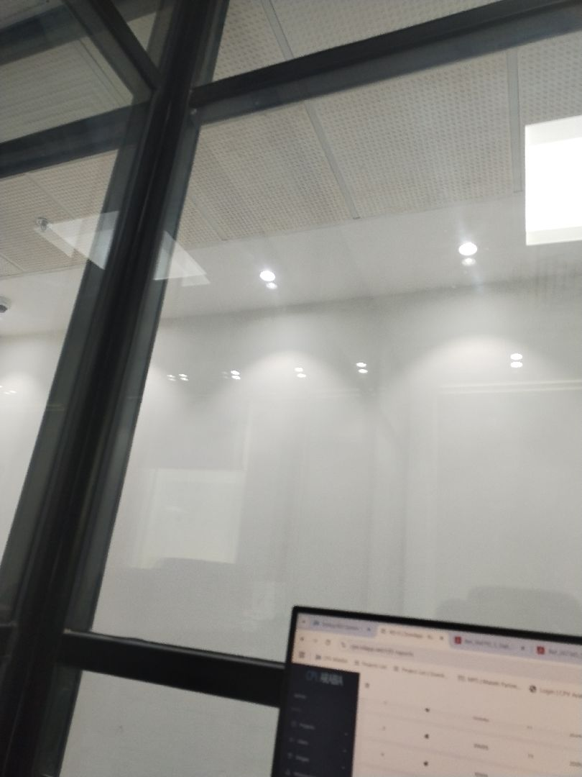

General site picture and construction plans

Risk Assessment

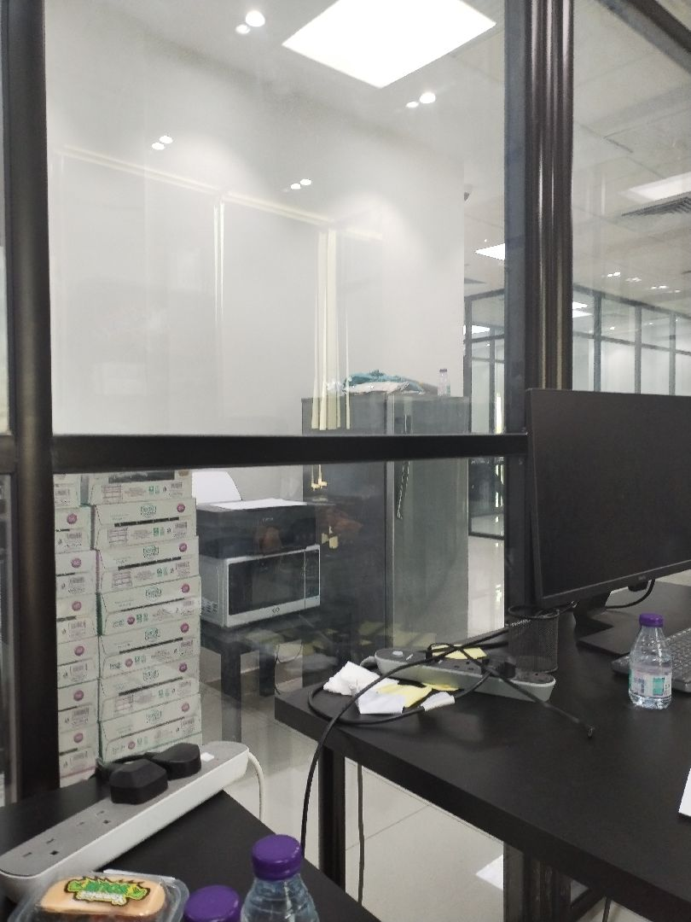

There are no defects in the facade waterproofing
Passed
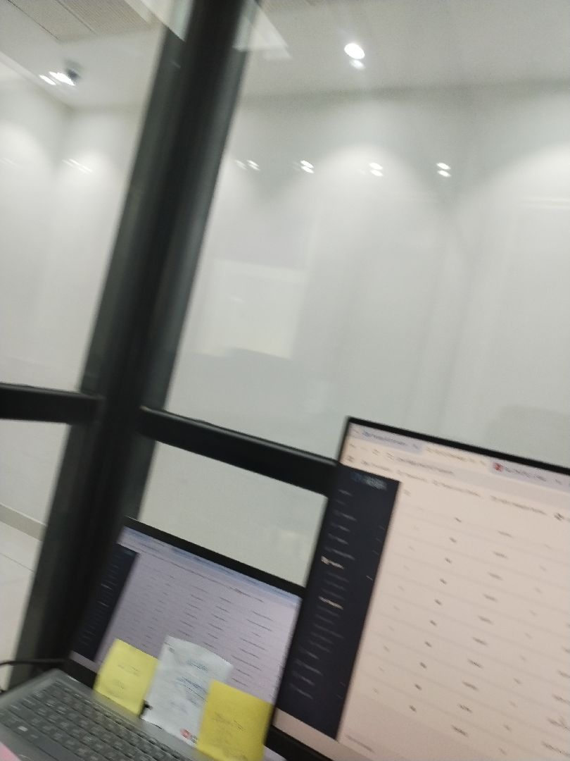

There are no defects in the facade waterproofing
Passed
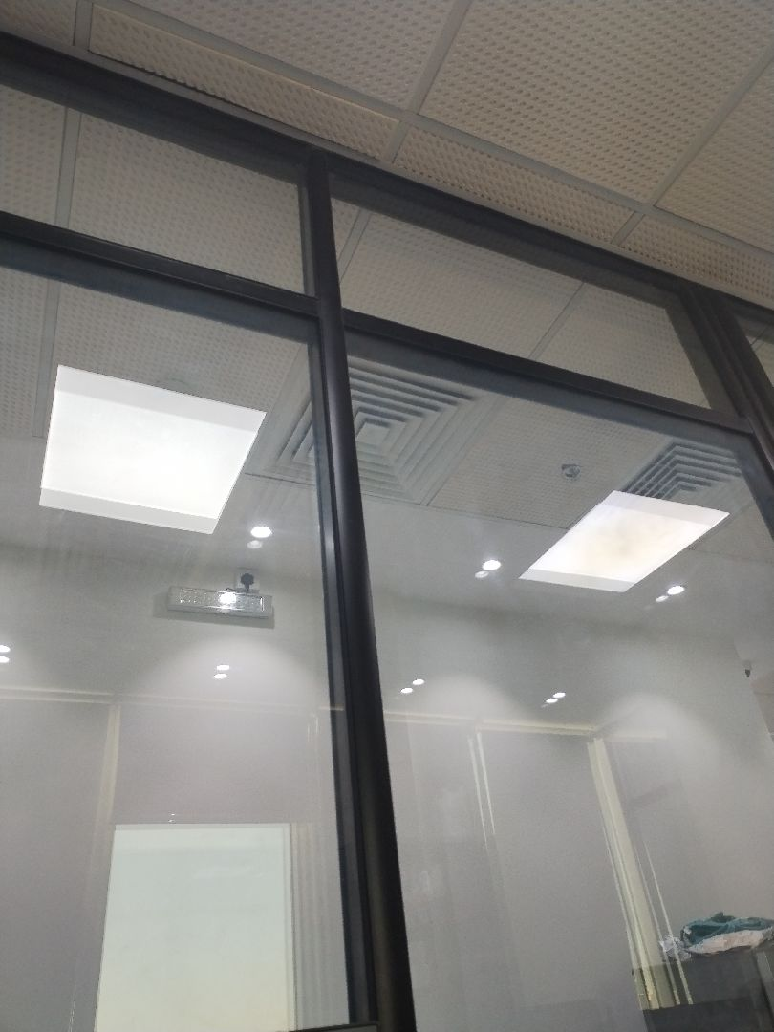

There are no defects in the facade waterproofing
Passed
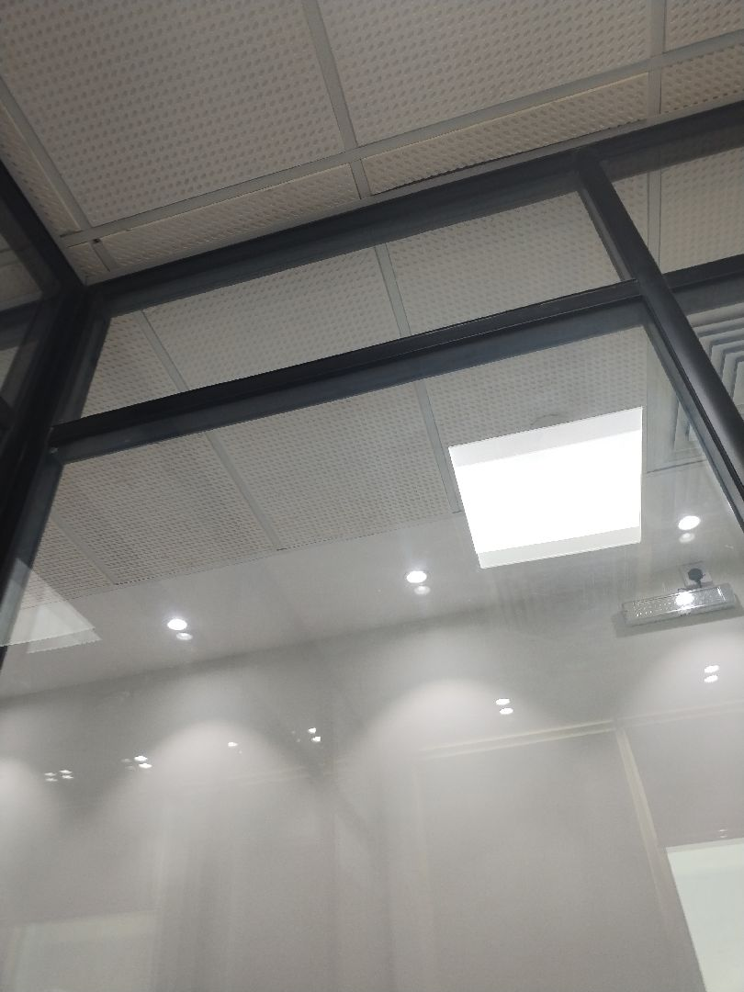

There are no defects in the facade waterproofing
Passed
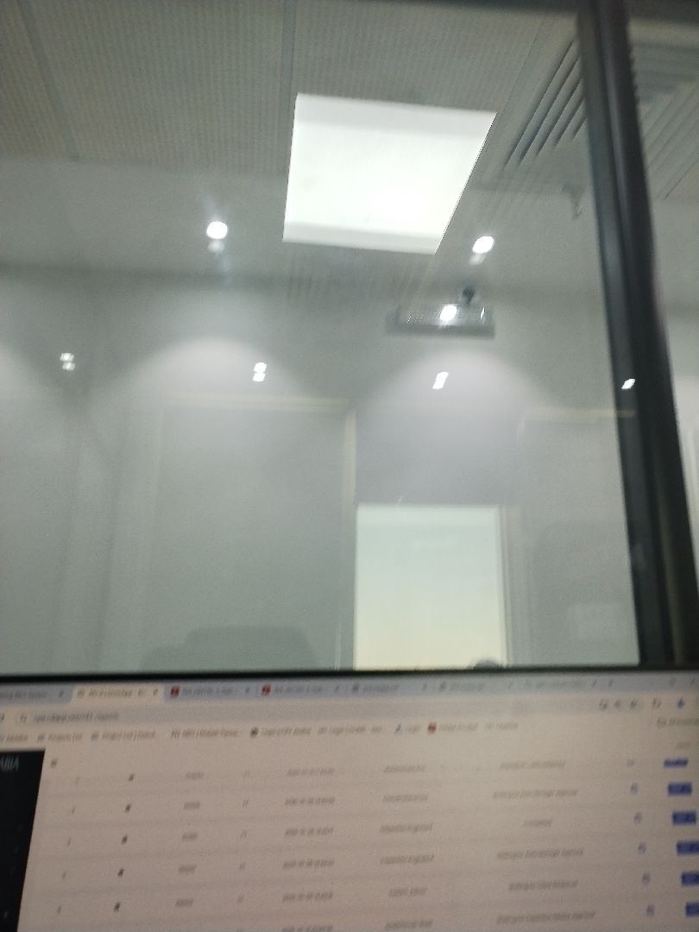

There are no defects in the roof waterproofing
Passed
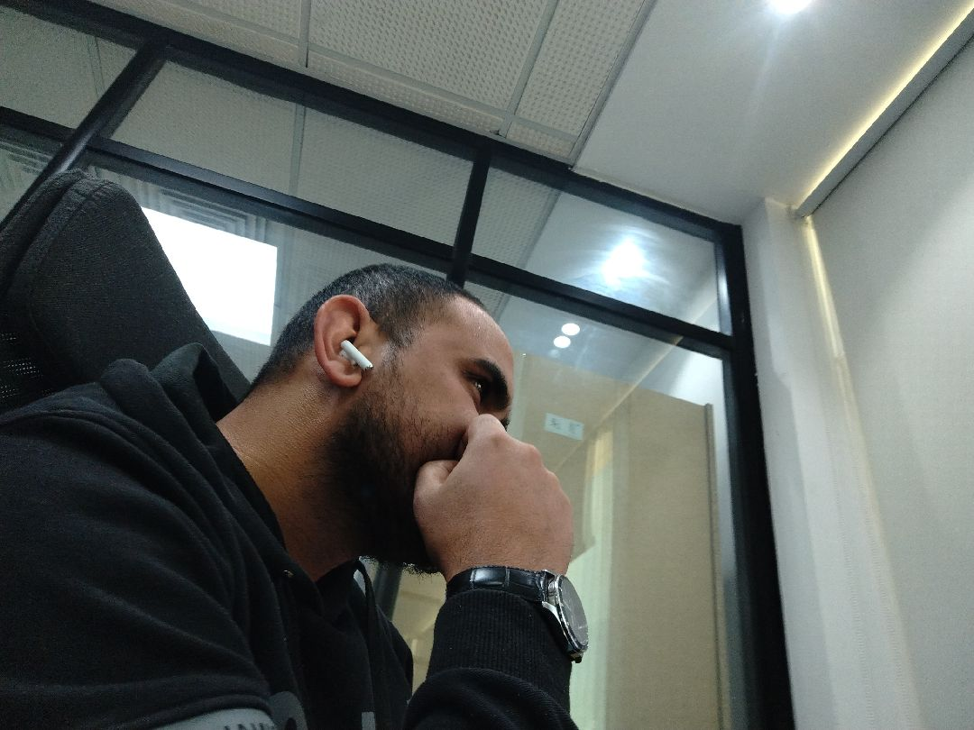

There are no defects in the roof waterproofing
Passed
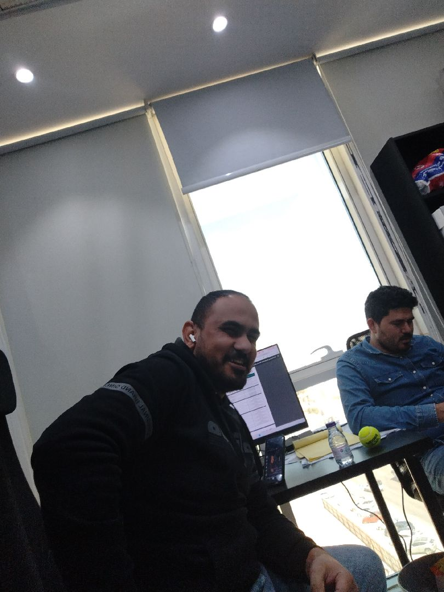

There are no defects in the roof waterproofing
Passed
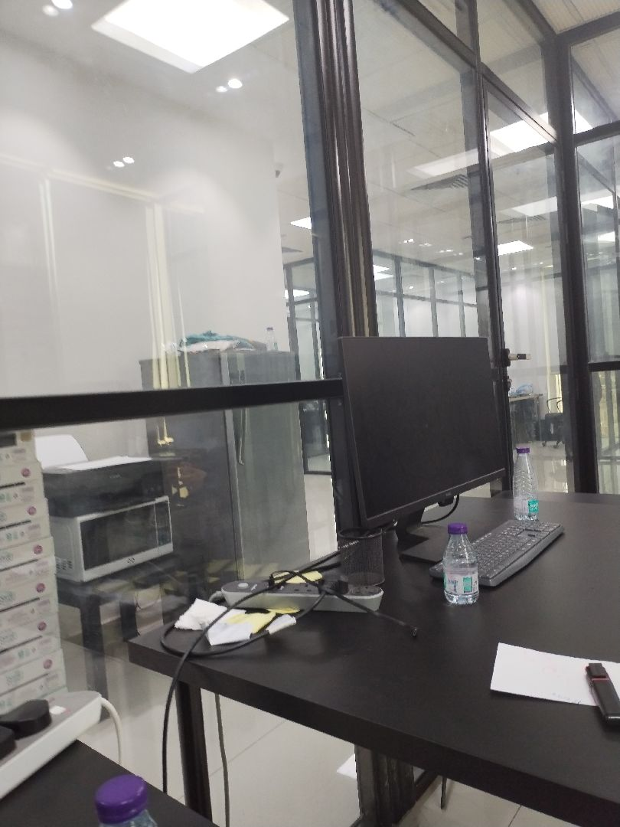

There are no defects in the roof waterproofing
Passed

Engineer In Charge of Inspection | Area Manager | Technical Inspection Manager
Name: Mahmoud Al Moghazi | Name: | Name:
Signature:   | Signature: | Signature:
Date of Issuing the report:

