${QR}

Attention to: ﻣﺆﺳﺴﺔ ﺛﺎﻳﺐ ﺑﻦ ﻋﻮﻳﺾ ﺑﻦ ﻋﺎﻳﺪ ﺍﻟﻤﻄﻴﺮﻱ ﻟﻠﻤﻘﺎﻭﻻﺕ

IDI PR #: 92001
Established by: Durid Mahrous

TIS Visit

Inspection Report - Retaining walls

Date of visit: 26-Feb-2025

Location: 24.6722455,46.7282918

( Inspection Department, Saudi Arabia)

Owner | ﻣﺆﺳﺴﺔ ﻣﺸﻌﻞ ﻓﻬﻴﺪ ﺣﺒﻠﻴﺺ ﺍﻟﻤﻄﻴﺮﻱ ﻟﻠﺘﻄﻮﻳﺮ ﺍﻟﻌﻘﺎﺭﻱ | TIS Company | CPV Arabia
Contractor | ﻣﺆﺳﺴﺔ ﺛﺎﻳﺐ ﺑﻦ ﻋﻮﻳﺾ ﺑﻦ ﻋﺎﻳﺪ ﺍﻟﻤﻄﻴﺮﻱ ﻟﻠﻤﻘﺎﻭﻻﺕ | Report Issue Date
Project Location | ﻋﻨﻴﺰﺓ | Inspection # | 1
Inspection Stage | Retaining walls | No. Of buildings | 1
Inspector Name | Durid Mahrous | Work in progress | Retaining walls
Email | dmahrous@cpvarabia.com | Telephone | 581089419

Inspection Results: Satisfactory with Technical Reservation
Description of the inspections carried out:

CPV ARABIA has conducted an on-site technical inspection (IDI) for Project PR #92001 during the pre-pouring phase of the Retaining walls .

The details of the inspection are described further as we go through this report.
Summary

Risks Assessment:
- Not exist
Stages missed without TIS involvement:
- Not exist
Interpretation of Additional Visit:
- Not exist
Technical Reservations (To be closed by providing the required certificates and reports before the final visit):
- Additional steel reinforcement is not according to the construction plans, which will affect the resistance of the bending moment for the structural element. The Additional steel reinforcement should comply with construction plans and saudi building code
Note:
- the longitudinal reinforcement diameter and number are not executed as per the construction drawing

General Site Pictures and Construction Plans
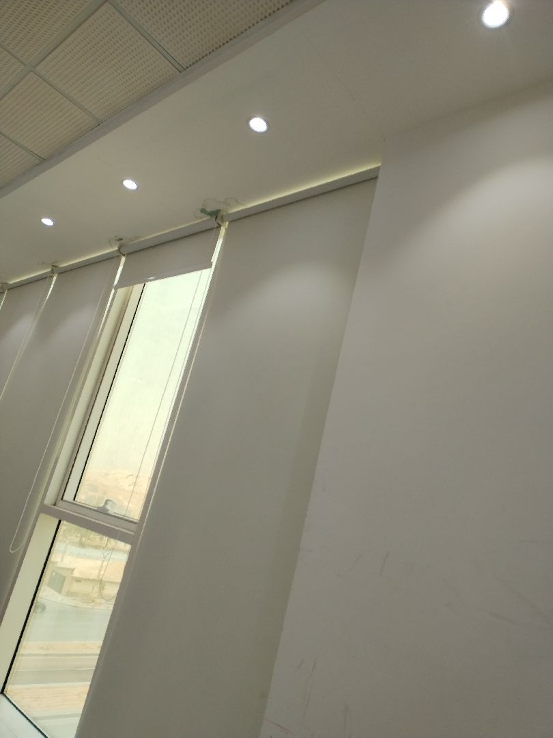
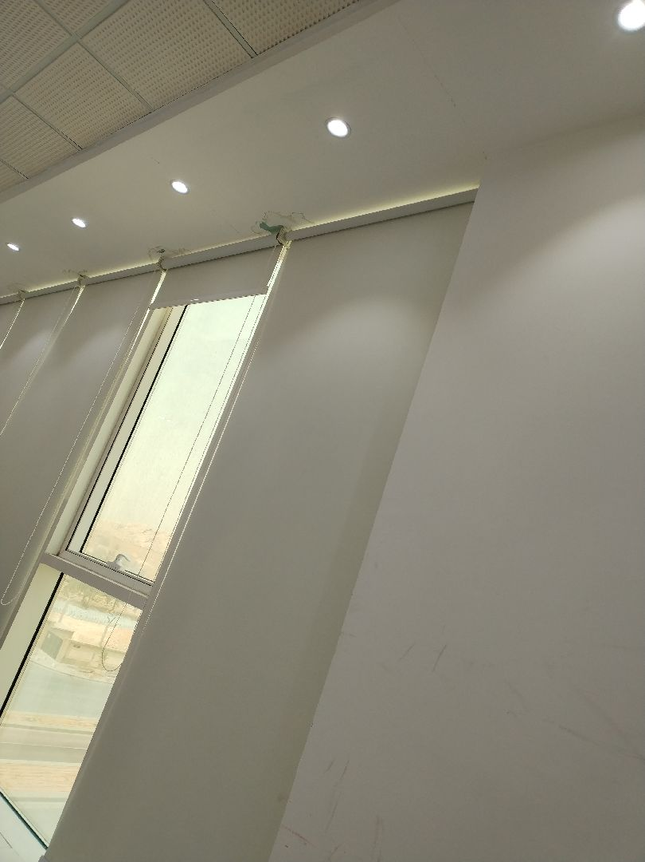

General site picture and construction plans

Checklist

No | Checklist | SBC Reference | Result | Remarks
1 | Inspection criteria
1.1 | Is the site ready for inspection with safe inspection conditions and safe access for the TIS inspection? | - | Passed
1.2 | Were there any modifications in the project that is different from the RD0, Soil Report and Construction Plans...etc.)? | - | Passed
1.3 | Is there any missing inspection stages in the project? | - | Passed
1.4 | Are there any defects observed that can affect the building’s stability or RD5 inspection for slab stage hasn’t been closed yet? |  | Passed
1.5 | Has the client provided verified concrete compressive strength test results? |  | Passed
1.6 | Is the laboratory conducting tests certified by an ISO/17025-accredited body? | - | Passed
2 | Formwork
2.1 | Are the forms clean and ready for pouring concrete? | - | Passed
2.2 | Is the formwork assembly stable due to the different loads? | - | Passed
2.3 | Were Concrete covers maintained as per approved drawings? | - | Passed
3 | Steel Reinforcement
3.1 | Are the longitudinal reinforcement diameter and number executed as per the construction drawing? | - | Passed
3.2 | Was the Water-stop installed as per the drawings? | - | Passed
3.3 | Is the length of splices according to the SBC specifications? | - | Passed
3.4 | Is the anchorage length of steel reinforcement at the corners of the retaining walls according to the SBC specifications? | - | Passed
3.5 | Is the steel reinforcement free from rust, oil, and contaminants? | - | Passed
3.6 | Are the tie wires installed as required? | - | Passed
3.7 | Are the bends bars within the radius and tolerance uniformly made? | - | Passed
3.8 | Is the thickness of the Retaining walls complying with the construction plans? | - | Passed
3.9 | Do the diameter, quantity, direction, and spacing of the additional longitudinal reinforcement at intersections, openings, and corners comply with the plans? | - | Not Passed
3.10 | Are the pipe sleeves installed as per engineering principles? | - | Passed
3.11 | Are the horizontal reinforcement diameter and number executed as per the construction drawing? | - | Passed

Risk Assessment

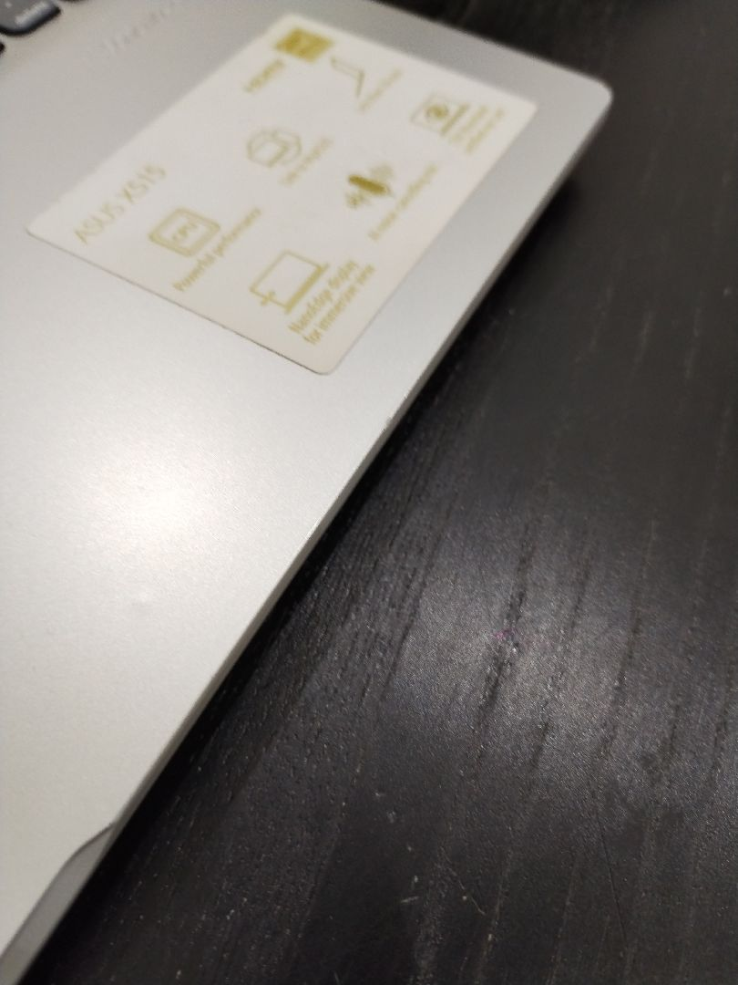

the horizontal reinforcement diameter and number are executed as per the construction drawing
Passed
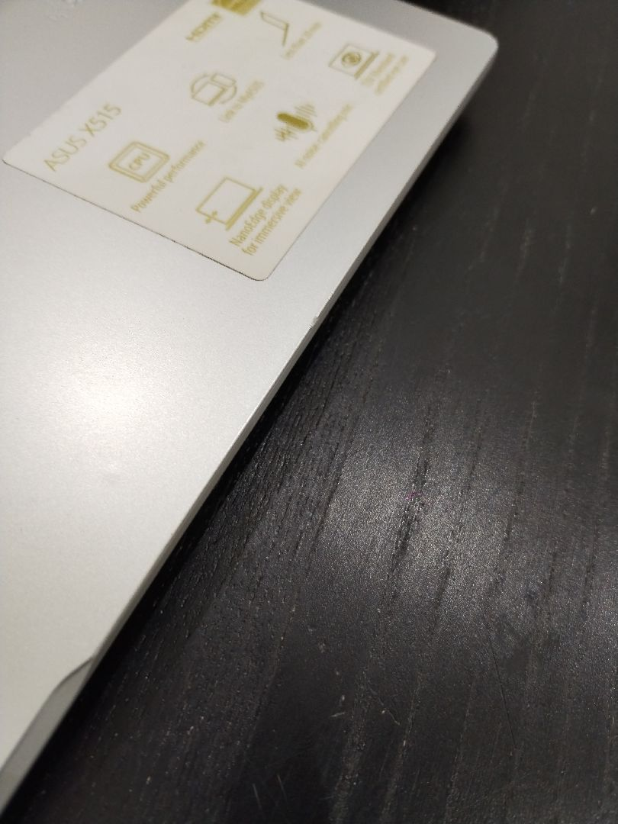

Additional steel reinforcement is not according to the construction plans, which will affect the resistance of the bending moment for the structural element.
Not Passed
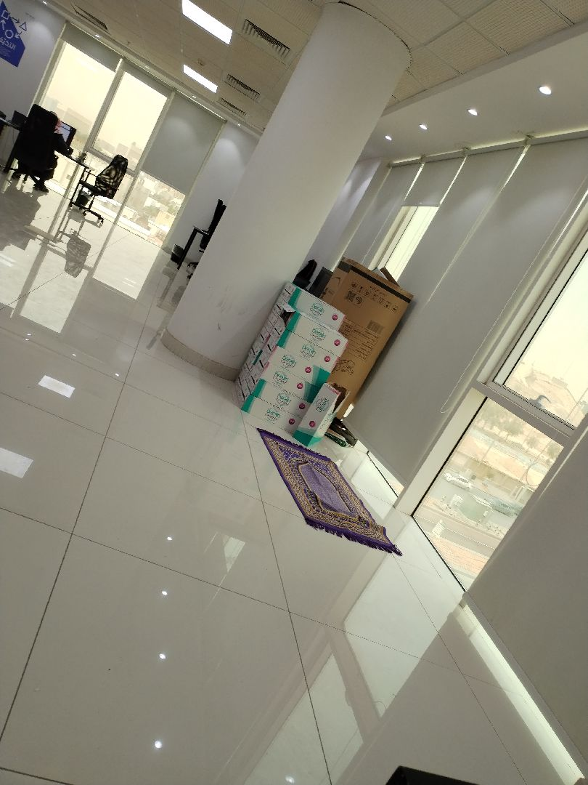

Retaining wall thickness
Passed
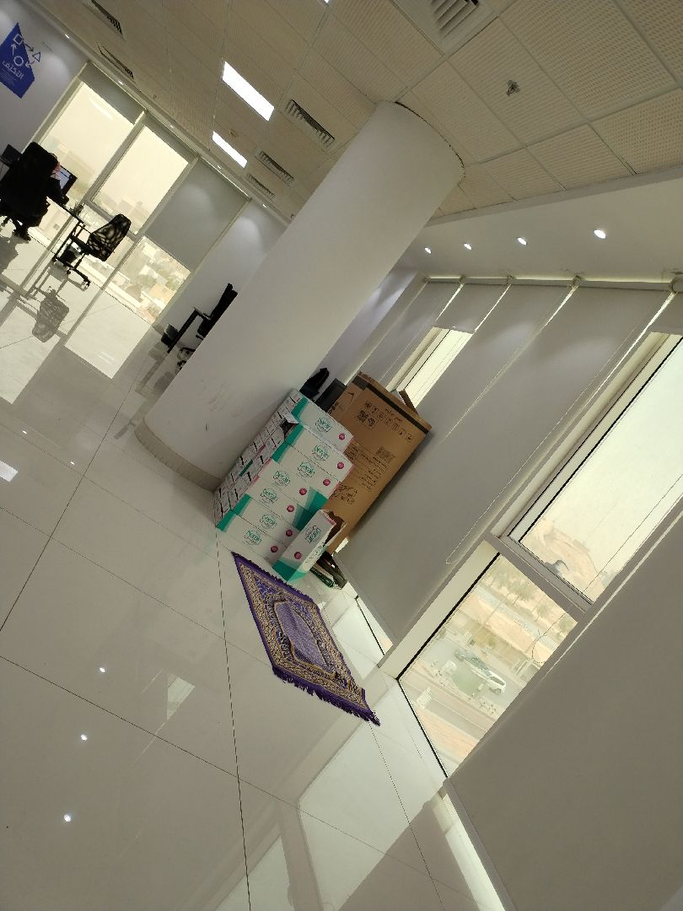

Bent bars
Passed
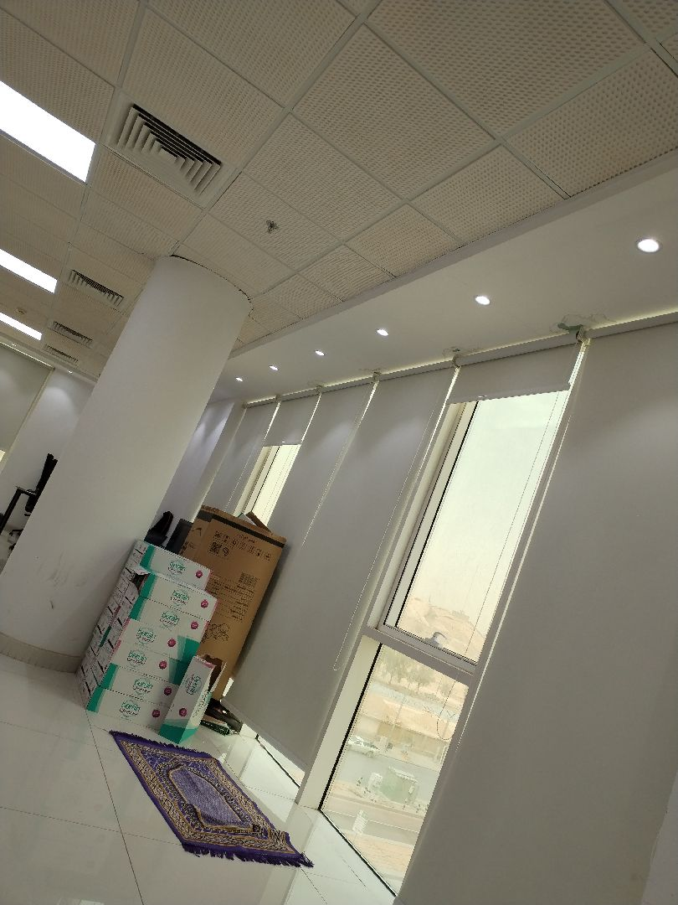

The Anchorage length of the retaining walls steel reinforcement at corners
Passed
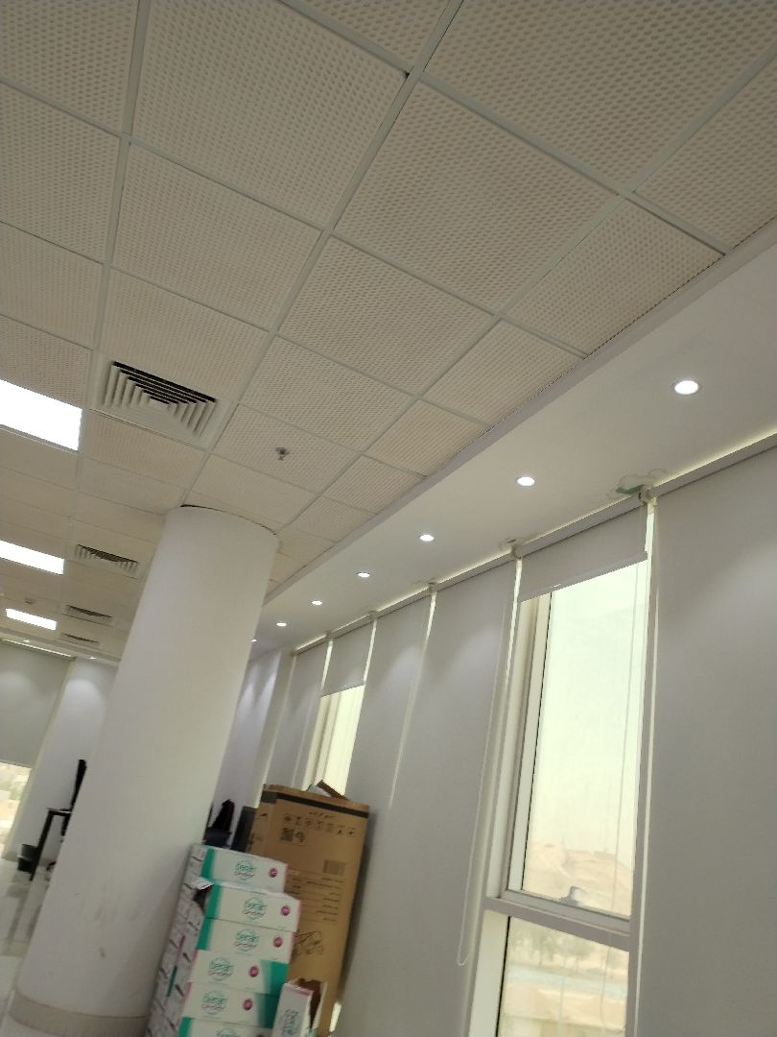

The splice length
Passed
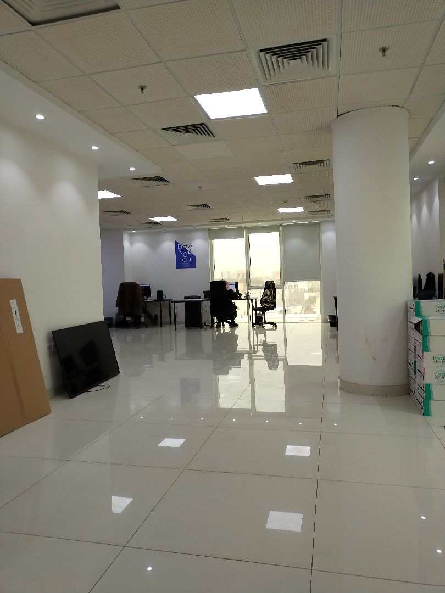

Was the Water-stop installed as per the drawings?
Passed
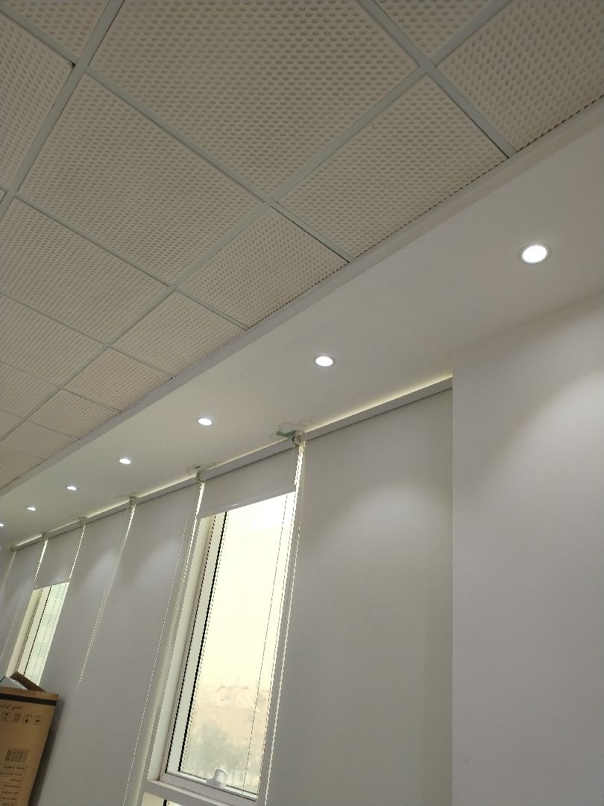

the longitudinal reinforcement diameter and number are not executed as per the construction drawing
Passed
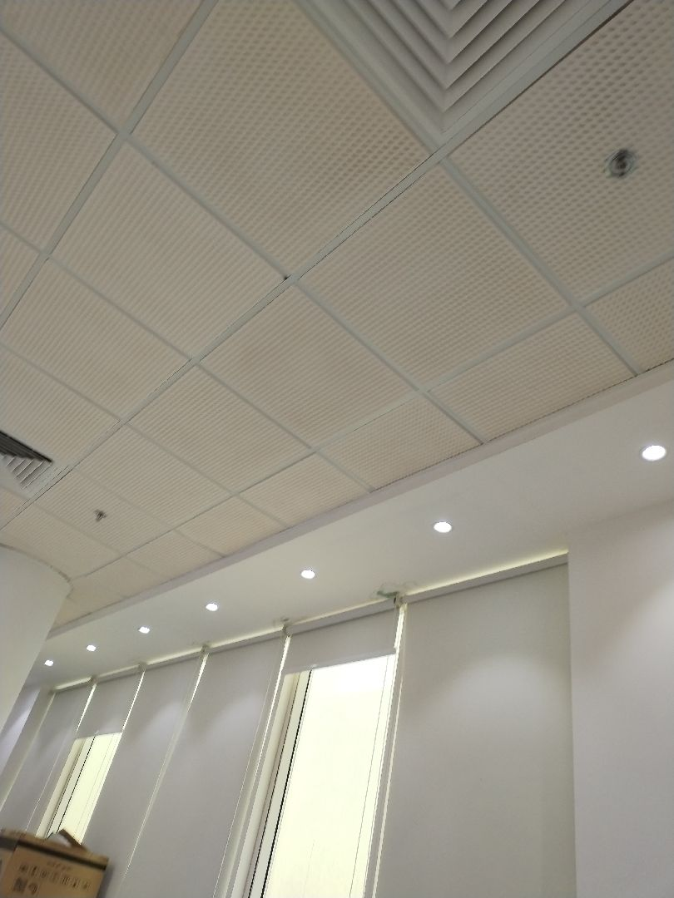

Concrete Cover
Passed

Engineer In Charge of Inspection | Area Manager | Technical Inspection Manager
Name: Durid Mahrous | Name: | Name:
Signature:  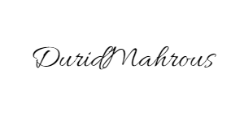 | Signature: | Signature:
Date of Issuing the report:

